AI Powered HR Recruitment System



Department of Computer Science

Zunaira Akbar | NUM-BSCS-2022-34
Umair Ahmad | NUM-BSCS-2022-36

2022 - 2026

Final year project report submitted in partial fulfillment of requirement for degree of Bachelor of Science in Computer Science
Namal University,
30-KM, Talagang Road, Mianwali, Pakistan.
www.namal.edu.pk

DECLARATION

The project report titled “AI Powered HR Recruitment System” is submitted in partial fulfillment of the degree of Bachelor of Science in Computer Science, to the Department of Computer Science at Namal University, Mianwali, Pakistan.

It is declared that this is an original work done by the team members listed below, under the guidance of our supervisor “Mr. Abdul Rafay”. No part of this project and its report is plagiarized anywhere, and any help taken from previous work is cited properly.

No part of the work reported here is submitted in fulfillment of requirement for any other degree/ qualification in any institute of learning.

Team Members University ID Signatures

Zunaira Akbar NUM-BSCS-2022-34 ___________________
Umair Ahmad NUM-BSCS-2022-36 ___________________

Supervisor Co-Supervisor
Mr. Abdul Rafay Ms. Asiya Batool

Signatures with date Signatures with date

__________________________ __________________________

Table of Contents
Abstract 8
Chapter 1 9
Introduction 9
1.1 Purpose 10
1.2 Scope 10
1.3 Definitions, Acronyms, and Abbreviations 11
1.4 References 13
1.5 Overview 14
Chapter 2 15
System Description 15
Literature Overview 15
2.1 Overall Description 18
2.1.1 User Characteristics 19
2.2 System Environment 19
2.2.1 Hardware Requirements 20
2.2.2 Software Environment 20
2.2.3 Operating Conditions 21
2.2.4 Integration Environment 21
2.3 Product Perspective 22
2.3.1 System Context and Boundaries 22
2.3.2 Relationship to Existing Systems 22
2.3.3 Interfaces with External Systems 23
2.3.4 Internal Component Relationships 23
2.3.5 User Workflow Integration 23
2.4 Product Features 24
2.4.1 Job Posting and Management 24
2.4.2 Resume Upload and CV Analyzer 24
2.4.3 Application Autofill and Editing 24
2.4.4 Candidate Job Matching 25
2.4.5 HR Review and Shortlisting 25
2.4.6 Automated Interview Invitation 25
2.4.7 AI-Based Interview Analysis 25
2.4.8 Chatbot for Candidate Support 25
2.4.9 Final Decision and Email Automation 25
2.4.10 Recruitment Tracking and Records 25
Chapter 3 26
Analysis and Design 26
3.1 Functional Requirements 27
3.1.1 Job Management (HR) 27
3.1.2 Candidate Registration and Application 27
3.1.3 Resume Parsing and Auto-Fill 27
3.1.4 Job Recommendation and Matching 28
3.1.5 Candidate Shortlisting 28
3.1.6 Interview Scheduling 28
3.1.7 AI-Powered Interview and Analysis 29
3.1.8 Candidate Communication and Chatbot 29
3.1.9 Final Evaluation and Decision 29
3.2 Non-Functional Requirements 29
3.2.1 Performance Requirements 30
3.2.2 Security Requirements 30
3.2.3 Usability Requirements 30
3.2.4 Reliability Requirements 31
3.2.5 Maintainability Requirements 31
3.2.6 Scalability Requirements 31
3.2.7 Compliance and Ethical Requirements 31
3.3 System Models 32
3.3.1 Data Flow Diagrams (DFD) 32
3.3.2 Use Case Diagrams 34
3.3.3 ER Diagram 41
3.3.4 Sequence and Activity Diagrams 42
3.4 External Interface Requirements 50
3.4.1 User Interfaces 50
3.5 Constraints and Limitations 58
3.6 Assumptions and Dependencies 61
Chapter 4 63
Remaining Work Plan (Sprint-Based Timeline) 63
Scrum-Based Milestones Summary 64
Development Approach Alignment 65
References 66

List of Figures
Figure 1 DFD level 0 32
Figure 2 DFD level 1 33
Figure 3 Use Case Diagram Job Management 34
Figure 4 Use Case Diagram Candidate Application 35
Figure 5 Use Case Diagram HR Shortlisting Approval and Emails 36
Figure 6 Use Case Diagram AI Matching and Ranking 37
Figure 7 Use Case Diagram AI Video Interview and Report 38
Figure 8 Use Case Diagram Candidate Support Chatbot 39
Figure 9 Use Case Diagram HR Final Decision and Email Automation 40
Figure 10 ERD 41
Figure 11 Sequence Diagram Job Management 42
Figure 12 Sequence Diagram Candidate Application 43
Figure 13 Sequence Diagram AI Matching and Ranking 44
Figure 14 Sequence Diagram Shortlisting Approval Email 45
Figure 15 Sequence Diagram AI Video Interview 46
Figure 16 Sequence Diagram HR Final Decision 47
Figure 17 Sequence Diagram Chatbot 48
Figure 18 Activity Diagram 49

List of Tables
Table 1 Work Plan 63
Table 2 Milestones Summary 64

Abstract
This project responds to major hurdles employers encounter during modern recruitment. Handling high application numbers becomes easier through automated processing, while faster decision cycles shorten overall hiring duration. Unconscious bias sees reduction via structured evaluation methods instead of traditional screening. Matching applicants to roles relies on dynamic profiling rather than static keyword checks. A core AI-driven HR platform supports these improvements across the entire workflow. Job postings initiate the process, followed by resume intake, shortlisting, interviews, and offering generation all integrated within one environment. Future development focuses on reading emotional cues during video assessments, not just spoken answers. Predictive modeling helps estimate both performance potential and how long someone might stay in a role. Connections to external business software allow smoother data flow beyond isolated talent systems. Algorithm updates occur regularly, ensuring alignment with evolving ethical guidelines plus international regulations around personal information handling. Smarter ways to sort resumes come from language-focused tech that reads skills closely. Candidate rankings emerge through pattern-learning systems trained on hiring data. Video interviews get analyzed by image-reading software spotting subtle cues in expression and movement. Scheduling eases when calendars automatically to fill time slots without back-and-forth. Chatbots reach out at key moments, keeping applicants informed with little human effort needed. Understanding both words and tone improves as newer artificial intelligence models power each interaction. Repetitive steps fade into background work while teams gain clear observations from collected information. Fair choices grow easier with evidence guiding who moves forward. Hiring workflows stay connected from job postings to offer letters all within one view. Future updates aim to detect emotions more accurately during recorded responses. Predictions about long-term fitness may soon shape early screening decisions. Broader links to company software will tie hiring into larger business functions. Updates continue regularly so fairness stays built into how machines learn and decide.

Chapter 1

Introduction
Finding and hiring new employees has turned out to be a struggle for most companies. Human Resources (HR) departments find it hard to cope with the huge amount of job applications that usually come in daily, and this has made the hiring process time consuming and difficult to control. The traditional approach of going through every resume, making decisions based on personal judgement of interviews, and managing hiring through scattered emails and calendars is simply no longer sustainable. Consequently, the one-open position lasts for too long, the good ones are passed up, the applicants get a slow or rather unclear update, and the HR personnel are occupied with the monotony of administrative tasks instead of evaluating new better hiring decisions. Simultaneously, the new requirements concerning fairness and data privacy complicate the recruitment even further.
Candidates too suffer from the difficulties of the traditional hiring process. A lot of candidates have to repeatedly fill out lengthy forms repeatedly even when the information is already in their CV. This tedious data entry consumes time, is annoying, and elevates the risk of errors. Also, the candidates are not aware of what is going on with their application, they do not expect a prompt response, and there is no visibility into the status of their application all these negatively impact their experience.
To solve these common problems, the project plans to devise an AI-Powered HR Recruitment System. The objective is to speed up the recruitment process and make it not only fairer but also smarter for both HR professionals and job seekers. The system will lessen the HR burden through automatic resume reading, shortlist creation, AI-aided interview assessment, and email and updates generating communication. The application process will be simplified for the candidates as the new system will take most of the information straight from the uploaded CV and automatically populate most of the application fields. In the process, candidates will only have to provide the information that is lacking and is not contained in the resume, thus making the procedure faster and more convenient.
The project will primarily aim to robotize the dull and repetitive recruitment tasks, enhance the precision of candidate-job matching, eliminate by a large extent the influence of human factors in hiring decisions, and finally, give all stakeholders a better experience. The project will be labelled a success when it can show that it has reduced the time-to-hire, produced accurate and useful shortlisting results, improved the satisfaction of both candidates and HR user, and has been reliably operating for the very recruitment workflows it was designed for.

1.1 Purpose
This Software Requirements Specification (SRS) document outlines the total requirement including all features and specifications of the AI-Powered HR Recruitment System. Its intention is to offer a straightforward and unequivocal portrayal of the system’s functional and non-functional requirements, constraints, scope, intended users, assumptions, and external interfaces.
This SRS is a document that all stakeholders including software developers, supervisors, testers, and potential users in the industry will refer to so that the system can be built, tested, and validated in a uniform way. The document delineates what functions the system is expected to perform such as resume processing, semantic matching, shortlisting, interview scheduling, candidate communication, reporting, etc. and the quality standards the system will have to meet namely performance, security, usability, reliability, and compliance.
The formal document of these requirements assists in reducing ambiguity, giving support to project planning and development, and providing a stable baseline for system verification, validation, and future enhancements.

1.2 Scope
The goal of this project is to create an AI based HR recruitment system that would be a great facilitator for the hiring process, turning it into an easier, quicker, and better organized way of getting from both the side of the companies and the side of job applicants. The primary aim of the system is to cut down the manual work done in recruitment and at the same time support the fair and consistent hiring decisions in the real organizational environments.
The system seeks to ease the daily tasks of the HR teams especially in recruitment, such as going through a huge number of resumes, making a list of suitable candidates, arranging interviews, and conducting these cases. The system when placed in the hands of HR staff acts as the best assistant who automatically organizes all applicant information, ranks the candidates in order of their qualifications against the job in question and takes care of all communication that is not very important. Thus, it allows HR staff more time to do their core work of assessing candidates and making decisions based on their insights rather than on the clerical part.
Besides, the applicant's experience is greatly affected by the system in that he/she does not have to go through the tedious process of filling in long and repetitive application forms as before. The applicant's personal and professional information is mostly taken automatically from the uploaded resume, and the applicant is just required to fill in the gaps. Moreover, the system updates the applicants through the automated messages about their application status, interview schedule, and the next steps thus making the whole process less of a challenge and more transparent.
The core features of the project are posting jobs and managing the applications, by means of resume analysis, selection of candidates, help in scheduling of interviews, provision of basic interview assistance, communication automation, and supervision over the offer management process. The system can be utilized in an industrial environment by small or medium-sized companies to manage a lot of applications for jobs, cut down on the time to hire, make it easier for HR teams and candidates to work together, and to ensure that hiring practices are more open and fairer.
Only recruitment activities are involved in this project. Other HR functions that are excluded are payroll management, attendance tracking, employee performance evaluation, and post-hiring employee management.

1.3 Definitions, Acronyms, and Abbreviations
To ensure consistent understanding and interpretation of this document, the following terms, acronyms, and abbreviations are defined:
- Talent Acquisition: A strategic approach to finding, attracting, and onboarding suitable candidates.
- Time-to-Hire: The time from posting a job to a candidate accepting the offer.
- Quality of Hire: A measure of how valuable a new hire is to the organization.
- Computer Vision: AI that interprets and analyzes images and videos.
- Transformer Architecture: A deep learning model design used for strong language understanding.
- Microservices: Building an application as smaller services that work together.
- Containerization: Packaging an application with its environment so it runs consistently anywhere.
- BERT: Bidirectional Encoder Representations from Transformers
- STT: Speech-to-Text
- TTS: Text-to-Speech
- OCR: Optical Character Recognition
- GDPR: General Data Protection Regulation
- SSO: Single Sign-On
- CRM: Candidate Relationship Management
- Talent Pipeline: A ready pool of potential candidates for future hiring needs.
- Candidate Experience: How candidates feel and respond during the recruitment process.
- Employer Branding: Promoting an organization as a desirable place to work.
- Diversity Hiring: Recruiting from different backgrounds to build a diverse workforce.
- Structured Interview: Same pre-planned questions asked in the same order to all candidates.
- Behavioral Interview: Questions about past behavior to predict future performance.
- Competency Framework: A structured set of required skills/competencies for roles.
- Offer Management: Creating, sending, negotiating, and tracking job offers.
- Onboarding: Helping a new employee settle into the organization and role.
- Recruitment Funnel: The stages a candidate passes through during recruitment.
- Semantic Matching Score: A score showing match quality based on meaning, not only keywords.
- Fit Score: An overall score combining different factors for candidate suitability.
- Behavioral Analysis Score: A score based on video interview analysis of soft skills/personality.
- Parser Confidence Score: A measure of how accurate the resume parser output is.
- Chatbot Session: A full conversation between a candidate and the chatbot system.
- Interview Analytics: Insights and results generated from video interview analysis.
- Recruitment Dashboard: A screen showing key recruitment information for decision-making.
- Pipeline Health Metrics: Indicators showing the efficiency and status of the recruitment pipeline.
- Bias Detection Algorithm: Methods used to identify and flag unfair bias in recruitment.
- Compliance Check: Automated checks to ensure recruitment follows laws and policies.
These definitions provide clarity for all readers of this document and ensure consistent interpretation of key terms throughout the project lifecycle. Additional terms may be defined in specific sections as needed for technical precision.

1.4 References
[1] Internal Project Document, “Proposal: Intelligent AI-Powered HR Recruitment System,” Final Year Project Proposal, Department of Software Engineering, 2026.
[2] Internal Project Document, “HR System Workflow,” System Workflow and Process Description Document, Department of Software Engineering, 2026.
[3] ISO/IEC/IEEE, “ISO/IEC/IEEE 29148:2018 – Systems and Software Engineering: Requirements Engineering,” International Organization for Standardization, Geneva, Switzerland, 2018.
[4] ISO/IEC/IEEE, “ISO/IEC/IEEE 12207:2017 – Systems and Software Engineering: Software Life Cycle Processes,” International Organization for Standardization, Geneva, Switzerland, 2017.
[5] IEEE Computer Society, “IEEE Std 830-1998: IEEE Recommended Practice for Software Requirements Specifications,” IEEE, USA, 1998.
[6] Department of Software Engineering, “Final Year Project Guidelines and Report Formatting Manual,” Academic Documentation, 2025.
[7] Course Material, “Software Requirements Specification (SRS) Writing Guidelines,” Lecture Notes and Slides, Department of Software Engineering, 2025.
[8] Internal Template, “Software Requirements Specification (SRS) Template,” Department of Software Engineering, 2025.

1.5 Overview
This document is organized to clearly describe the requirements, scope, design, and planned completion of the AI Powered HR Recruitment System.
Chapter 1 introduces the project by explaining the background, problems in current recruitment practices, project objectives, scope, key definitions, and references. It provides the context needed to understand why the system is proposed and what it aims to achieve.
Chapter 2 presents the system description. It explains the overall system behavior, user characteristics, operating environment, product perspective, and high-level features. This chapter helps readers understand how the system fits into real recruitment workflows and how HR users and candidates interact with it.
Chapter 3 focuses on analysis and design. It defines the functional and non-functional requirements, system models, external interfaces, constraints, and assumptions. This chapter translates the project goals into clear technical and operational requirements.
Chapter 4 outlines the remaining work and timeline. It presents the pending tasks, their status, sprint-based milestones, and completion schedule using an incremental and Scrum-based development approach.

Chapter 2

System Description
Recruiting for industrial companies has become an even more complicated process than before. The overwhelming number of applicants, the stricter hiring deadlines, the need for quick communication, and the always-present fairness and transparency requirement even in small decisions can make the whole process cumbersome. And there are still other factors that affect the decisions. All the manual tasks such as screening, candidate follow-up, interview scheduling, and document handling only increase the burden, prolong the hiring process, and make it difficult to evaluate candidates fairly and consistently. HR and management experts commonly view AI as a tool in this scenario that can increase productivity, deliver uniform evaluations, and support better choice-making. However, they always caution about the necessity of having proper systems and accountability when AI is involved in hiring decisions [1], [9].

Literature Overview
i. AI and NLP for CV or Resume Parsing and Auto-Fill
One of the most significant research fields that backs this project is resume parsing. In this process, NLP along with information extraction techniques are utilized to transform unstructured resumes into structured profiles which highlight skills, education, work experience, dates, and other relevant entities. Moreover, recent studies have suggested a distinct shift from conventional rule-based methods to deep learning and changeer models, which are more reliable in handling the variety of resume formats and writing styles [2], [4].
In real recruitment situations, a lot of resumes come as scanned documents or with complex layouts. The literature advises that the integration of OCR technology and subsequent NLP processing can significantly enhance the accuracy of data extraction from resumes in the real world [3].
Significance to the project: The study backs up the feature where a candidate uploads a resume, and the system takes care of filling in most application fields with the extracted data automatically. This way, candidates are only asked to add any missing information or correct fields, if necessary, thereby optimizing the process, cutting down on repetitive manual entry, and at the same time improving user experience [2], [3], [4].
ii. Skill Matching and Semantic Matching Between Resumes and Job Descriptions
Keyword matching through conventional approaches can occasionally miss out on potential candidates who are qualified because the way the skills are articulated varies among the candidates; a candidate could utilize different terms, shorthand, or jargon. To solve this problem, scholars advocate for the use of semantic matching based on deep learning word embeddings that aim at grasping the concepts expressed by the words and not just making term-to-term comparisons [5], [6].
Connection to the research: This method is in line with the part of the system that matches a candidate's profile with the job specification and results a match score that highlights the most appropriate candidates for the following step [5], [6].
iii. Shortlisting and Explainable Decision Support
The necessity of explainable AI is getting larger as the ranking systems that are AI-driven start to have a greater impact on the way people are hired. The recruitment process has this need the most, as it should always be possible to defend and review the decisions made. Different researchers have come up with the conclusion that "interpreting scores and giving recruiters the ability to tweak parameters via clear and understandable reasoning" is one of the main factors [7], [8].
Relating this to our project: The scoring of candidates is done by our system which also makes a ranked list to facilitate the HR teams in the shortlisting process. Moreover, it keeps the HR in control and guarantees that they are the ones who decide which candidates go ahead, and that they can support their decisions with easy, score-based evidence [7], [8].
iv. AI-Driven Interview Analysis and Bias Concerns
One more research direction investigates the potential of AI in supporting assessments through interviews by monitoring not only the speech but also the visual signals, i.e. facial expressions, eye contact, vocal characteristics and even what the candidates are saying. The research imply that the integration of various data types can lead to the identification of substantial markers that will support the evaluation process [9], [10], [11]. The slower recognition of the ethical and bias issues, however, that are involved, has called for carefulness in management, transparency and human supervision, not to mention, obtaining clear consent [10].
Relevance to this project: This goes hand in hand with the AI-supported interview module, where a report is generated by the system after an interview, which consists of the scores and markers, like, for instance, the levels of trust and the ability to communicate. The human HR professionals are the ones who look at these results and not just the automation that is why they have to be constantly heard in the hiring [9], [10], [11].
v. Automated Candidate Communication and Chatbot Support
Research has indicated that giving updates in a timely manner greatly improves the candidate experience while at the same time lightening the load on the HR departments. Several research works have confirmed that the use of chat-support platforms with automated notification systems has a positive impact on the reduction of repetitive communication and faster responding, especially in the busy recruitment periods [12], [13], [14].
Relevance to this project: This piece of evidence shows that a candidate portal chatbot for checking application status and answering FAQs, together with automated email alerts for interview scheduling, job offers, and rejections, would be valuable [12], [13], [14].
vi. Workflow Automation and End-to-End Integration
Recruitment studies have consistently pointed out that automation can provide the highest benefit when it is used to coordinate activities that are to be done at different stages, like screening, scheduling, evaluation, and communication of decisions, with minimum friction. Moreover, the integration of well-thought-out workflows is said to be a great source of efficiency and a means to avoid the wastage of resources through duplication [9].
Project relevance: The system is constructed as a holistic end-to-end solution that cohesively integrates processes like resume parsing and auto-fill, matching and scoring, HR review, sending out automated interview invites, AI-generated interview reports, final HR review, and automated communication of offers or rejections, all within a single platform.
Context for the Current Project
- From a comprehensive review of former research, one can only get a few central points - each one giving its own distinctive touch to the whole work. The first one is very much related to the actual world, indicating the spots where the previous attempts were unsuccessful. The second one concentrates on the hidden aspects in contemporary techniques. The thirds released to reconsider what is usually taken for granted. These factors constitute the setting under which the results are found, but they do not limit the results.
- Dealing with a huge number of candidates at the same time automatically makes hiring take a very modern turn and the use of automation becomes especially legitimate for the handling of resumes, texting, or even arranging interviews [1], [12].
- Reviewing methods go beyond just basic word checks; semantic matching really gives its precision by taking differences in wording into consideration, and the proof is provided by the studies that show it has an advantage over inflexible keyword methods [5], [6].
- Possibility of AI being used in the talent acquisition process still holds a lot of ethical considerations [10]. The criterion of fairness must be at the center the whole time. The process of making the decisions is to be facilitated with the help of transparency. Human assessment is to take every step slowly and carefully.

The present attempt, completely based on previous research, is taking shape as the first issuing tool which is not more than just two kinds of users: HR managers and candidates. While the former specifies the openings and reviews the candidate's information, the latter sends his/her resume. The moment it is uploaded, an automatic procedure brings forward the major points of the applicant's qualifications to the forms. The applicants then fill in the blanks, modify what has been extracted if they wish. Once the fully completed form is sent, a comparison device calculates how much each applicant corresponds with a certain position. After that, the strongest profiles buy HR the right to evaluate future hires while initial automated interview messages are sent out concurrently. At the conclusion of the assessment, the output displays not only the scores but also the self-confidence attributes such as verbal clarity. After that, the decision makers scrutinize the top candidates before the digital notifications are sent out - the offers are for the selected ones and the declines for the others. This technique has moved from the previous studies with their disorganized methods to one where the personnel departments’ tasks are made easier, and the applicants' perception of the process is made stronger [2], [5], [12].

2.1 Overall Description
The AI-Powered HR Recruitment System can be analyzed by considering the factors that determine its construction and application. User characteristics are significant because they will impact the selection of design and implementation options. The initially made presumption will determine the capabilities of the system later. Integration with current tools is also a very important external need. The organization's established priorities will influence the decisions made throughout the development. All these factors together dictate whether the system will be effective in real recruitment situations or not. It is not by chance that practicality comes out, but rather it is a result of being up to such details.

2.1.1 User Characteristics
The system is designed for two primary user groups:
- HR Users
Recruitment cycle management is the responsibility of HR personnel. The first step is to post the vacancies, then to filter the applications, determine the applicant's ranking, review the interview summaries done by the machine, and finally decide the selected candidate. A vast majority of people with digital skills ranging from very basic to average use machines but do not need sophistication in AI tools. Nevertheless, they have busy days, simplicity in layout, steps to take, and summaries of insights rather than sophisticated backend mechanics. Automation takes care of the routine tasks such as filtering resumes, picking the best candidates, sending messages, and scheduling interviews thereby freeing up time yet keeping the essential decisions with humans.
- Candidates
The candidates are sourced externally, gaining access to the system through a web-based portal. There are individuals who are very good at using technology, and there are others who hardly get along with it; the choice of the device is another factor that varies, ranging from smartphones to bigger screens. As these people are not taught anything, the interface’s behavior is guided by the dual aspects of clarity and simplicity. With the feature that enables uploading resumes, manual input decreases greatly since the in-built tool is already extracting the data and filling the forms automatically. Missing information can be provided by the applicants, who are also allowed to make corrections to the extracted data if necessary. It would be ideal to have clear instructions along with prompt updates to assist them. A chatbot that helps answering questions plays a big role in making the interactions throughout the process smoother.

2.2 System Environment
This segment describes the tools, programs, and circumstances that support the AI-Driven HR Hiring Platform. It functions as an online tool, running on regular computers and hosted servers suitable for both educational environments and small-sized teams. Even though the platform was designed with the possibility of scaling up, the basic configuration remains available without the need of specialized equipment. Accessibility influences a large part of the design and allows the use of common browsers without the need for additional installations. Maximum performance is guaranteed under normal network traffic, given the minimum internet speed. Security measures are in line with standard practices, and they are based on well-known and not experimental methods. Updates are done over the internet, which makes the maintenance burden on the users very light. Compatibility is with the latest versions of major operating systems that are used in corporate settings.

2.2.1 Hardware Requirements
The system is hosted on a cloud-based or university-provided server environment.
Client Hardware:
- HR Users:
A standard computer, whether a desktop or a laptop, is quite functional if it has an up-to-date browser. No less than 4 gigabytes of RAM guarantee efficient functioning during activities. For interview playback, a basic camera and audio input are required. Devices that fulfill these specifications process the review without any problems.
- Candidates:
Even though basic internet access is the main thing, still most devices such as laptops and cell phones get along well if they have a modern browser installed. In AI-facilitated interviews, ear and eye devices become the most important ones.
- Internet Connectivity:
It is a necessity to have a reliable internet connection. For video interviews, at least 5 Mbps should be the target for both upstream and downstream. The speed is more crucial when the picture is part of the communication.

2.2.2 Software Environment
Operating Systems:
- Server: Windows-based operating system (such as Windows Server 2019 or later)
- Client: Any operating system that supports modern web browsers, including Windows, macOS, Linux, Android, and iOS
Software Stack:
- Backend Development: Python (for business logic, resume parsing, matching, and interview analysis)
- Frontend Development: JavaScript with a web framework for user interfaces
- Database: A SQLite database will serve as the lightweight relational database for keeping structured recruitment data like users, jobs, applications, and decisions.
- Document Storage: Resume files and interview reports will be stored as local server files, with the SQLite database referencing the file paths.
- Web Browser: Chrome, Firefox, Edge, or Safari (latest versions recommended)

2.2.3 Operating Conditions
- The system has been planned in a way that it can run as a web application which is always available during the normal working hours of the organization.
- The resume parsing along with the matching is done after the application is submitted and is to be considered as not needing to be a real-time process.
- The analysis done by AI on the interviews is carried out after the interview is over and a report is produced for the human resources department to consider.
- The system can handle several users at the same time accessing the platform which is like the scale of an academic project.

2.2.4 Integration Environment
The system integrates with limited external services required for core functionality:
- Email Service: Used to send automated emails for interview details, offer letters, and rejection notifications.
- Calendar Integration: Used for interview scheduling support.
- Video Interview Platform: Used for conducting AI-based interviews and recording responses.
All integrations are handled through standard APIs.

2.3 Product Perspective
The AI-Powered HR Recruitment System is described in this section along with other systems and services that are typically used during the recruitment process. It aims to clarify the boundaries of the system, i.e., what is included, what is excluded, and through which external services the system could possibly interact to carry out recruitment tasks efficiently.

2.3.1 System Context and Boundaries
The system is a recruitment-focused platform that manages the complete hiring workflow from job posting to final decision communication.
Inside the system scope:
- HR takes responsibility for making the job posts and advertising them.
- The applicant carries out his/her own process by uploading the CV and submitting the application.
- The CV extractor takes out the data from the resume and automatically fills up the application.
- The matching module evaluates the candidate and gives a score based on the job description.
- The HR department looks at the best matches.
- The system by itself sends out an interview notice after the HR department's check-up.
- An AI-powered interview takes place, and a scoring report is produced.
- The HR department examines the candidates with the highest scores.
- Offer and rejection emails are issued without any delay.
- The candidate's online account has a chatbot for checking the status and asking questions.
Outside the system scope:
- Payroll, employee attendance, and employee performance management
- Management of complete HRIS employee records post employment

2.3.2 Relationship to Existing Systems
The system has been built as a stand-alone recruitment solution for the FYP. It does not depend on major enterprise systems. Nevertheless, it might link up with some standard applications to make the recruitment process smoother.

2.3.3 Interfaces with External Systems
The system may use basic external services to support its workflow:
- Email Service:
Used to send automated messages such as interview invitations, offer letters, and rejection notices.
- Calendar Integration (optional):
Used to support interview scheduling and reduce manual coordination.
- Video Interview Tool or Module:
Used to conduct AI-based interviews and generate an interview scoring report.

2.3.4 Internal Component Relationships
The main internal modules connect in a simple end-to-end flow:
- Human Resources’ job announcement is connected to applicants’ resumes
- Uploading a resume activates the process of CV parsing and the application form's data autofill
- After the application is sent, the matching module computes a score based on the job description
- The HR department then looks at the results and advances to the interview phase
- The examination of interviews produces a report along with ratings for HR's consideration
- The decision phase initiates the automatic sending of acceptance or rejection emails
- The chatbot is available to assist the candidate with questions and to provide updates on the application status

2.3.5 User Workflow Integration
HR Workflow:
- The Human Resources department publishes vacancies, evaluates applicants, makes a shortlist, and decides who gets hired.
- The solution takes off a lot of work from the HR department by automating parsing, scoring, sending interview invitations, and communicating the final decision.
Candidate Workflow:
- The applicant submits a resume, and the majority of the application form information is automatically filled in.
- The applicant just has to supply the missing information and is allowed to modify the data that was extracted prior to submitting.
- The applicant can monitor the application and communicate through the portal chatbot if necessary.
- The applicant gets notified by automation regarding the interview and the final verdict.

2.4 Product Features
In this part of the document, the main characteristics of the AI Powered HR Recruitment System are presented along with a short discussion about the objectives of each feature. All these functionalities together facilitate the entire hiring process for both HR personnel and applicants, at the same time lessening the manual labour and increasing the productivity.

2.4.1 Job Posting and Management
The software gives Human Resources the power to make, modify and control the job advertisements. Human Resources can insert information regarding the job like demands and texts, then the applicants can see the vacancies and apply for them through the system.

2.4.2 Resume Upload and CV Analyzer
The system allows the applicants to upload their resumes. The CV Analyzer, in a way, extracts information like education, skills, and experience automatically, which lessens the requirement for candidates to manually fill out lengthy application forms.

2.4.3 Application Autofill and Editing
The data that has been extracted from the candidate's resume is automatically input into the application form. The candidates have the option to add any information that is not present and can modify the data that has been filled in automatically before submitting the final application.

2.4.4 Candidate Job Matching
The system evaluates the candidate profiles against the job specifications and assigns a match score. This facilitates human resource to rapidly spot the best fitting applicants and backs up the selection process.

2.4.5 HR Review and Shortlisting
HR has the option to look at candidate profiles, matching scores, and application details in one location. Upon this review, HR will be the one to select candidates for the interview round.

2.4.6 Automated Interview Invitation
After the HR department gives the green light, the system takes over and automatically sends out interview invitation emails to the selected candidates, allowing for a significant reduction in manual communication effort.

2.4.7 AI-Based Interview Analysis
The system has AI-centric interview assessment feature. A report of the analysis is issued post interview, and it contains score indicators like confidence and communication-related note to help HR in making decisions.

2.4.8 Chatbot for Candidate Support
In the candidate portal there is a chatbot that can answer frequently asked questions, update the application status, and assist the candidates throughout the hiring process.

2.4.9 Final Decision and Email Automation
Based on responses to the interview and HR scrutiny, the system automatically generates offer and rejection emails for the respective candidates.

2.4.10 Recruitment Tracking and Records
The system keeps fundamental information on submissions, interview results, and final decisions. The HR department can then monitor the flow of new employees and ensure openness in the process.

Chapter 3

Analysis and Design
In this chapter, the dissection and design of the AI-Powered HR Recruitment System are given. It is a big step to carry out the implementation of the system via a clear technical and structural plan that is guided through a system of requirements defined earlier. The chapter at first tells the reader how the system is organized, how development is carried out, and how different parts of the solution work together to support the recruitment workflow.
The model followed for the development of this project is the Incremental Model together with Agile Scrum practices. Development is managed by Scrum in short, iterative cycles, allowing continuous feedback, gradual improvement, and early validation of working modules. The whole project is divided into several increments, and each increment delivers a part of the system that can be used rather than waiting for total completion at the end.
The work is divided into four main increments. The first increment is concerned with building the essential platform which encompasses job posting, candidate application handling, and resume parsing. The second increment adds features like candidate–job matching, automated communication, and chatbot support to the system. AI-based interview handling, and evaluation support are among the features added in the third increment. The last increment is directed towards the integration, stability, and optimization of the whole system. Each increment follows Scrum sprints composed of planning, implementation, testing, review, and retrospective activities.
Architecturally speaking, the system is created as a modular web-based application with a clear demarcation among user interface, application logic, and data storage. The frontend of the application has interfaces for HR users and candidates, while the backend of the application is responsible for recruitment workflows, data processing, and AI-based analysis. The data layer keeps all the information about the candidates, the jobs, the interviews, and the system in a well-organized way.
This part of the text highlights the main development strategy, the different components of the system together with the design choices that enable the project's recruitment process. The analysis and the design presented in this chapter are in accordance with the real scope of the FYP and depict the functionalities that have been already implemented or that are planned to be part of the AI Based HR Recruitment System.

3.1 Functional Requirements
The functional requirements for the AI Powered HR Recruitment System are defined in this part. The requirements illustrate the anticipated functioning of the system from the viewpoints of HR and Candidates and facilitate the entire recruitment process.

3.1.1 Job Management (HR)
FR-JM-001: The system shall allow HR to create job postings by entering job title, department, location, experience level, and required skills.
FR-JM-002: The system shall allow HR to edit job postings before and after publishing.
FR-JM-003: The system shall allow HR to delete job postings when required.
FR-JM-004: The system shall allow HR to close job postings once hiring is completed.
FR-JM-005: The system shall display the status of each job as open, closed, or filled.
FR-JM-006: The system shall allow HR to view all jobs posted by them.

3.1.2 Candidate Registration and Application
FR-CA-001: The system shall allow candidates to register using name and email address as mandatory fields.
FR-CA-002: The system shall allow candidates to log in and manage their profile.
FR-CA-003: The system shall allow candidates to upload their resume in supported formats.
FR-CA-004: The system shall allow candidates to apply for available jobs.

3.1.3 Resume Parsing and Auto-Fill
FR-RP-001: The system shall automatically parse uploaded resumes using a CV Analyzer.
FR-RP-002: The system shall extract candidate details such as name, education, experience, and skills from the resume.
FR-RP-003: The system shall automatically fill the application form using extracted resume data.
FR-RP-004: The system shall allow candidates to manually enter information missing from the resume.
FR-RP-005: The system shall allow candidates to edit auto-filled resume information before final submission.

3.1.4 Job Recommendation and Matching
FR-SM-001: The system shall display job recommendations to candidates based on their skills.
FR-SM-002: The system shall allow candidates to view all available jobs.
FR-SM-003: The system shall calculate a matching score between candidate profiles and job requirements.
FR-SM-004: The system shall generate separate technical skill and soft skill matching scores.
FR-SM-005: The system shall calculate an overall matching score using resume analysis and interview results.

3.1.5 Candidate Shortlisting
FR-CS-001: The system shall rank candidates based on their matching scores.
FR-CS-002: The system shall allow HR to view shortlisted candidates.
FR-CS-003: The system shall allow HR to manually review and confirm shortlisted candidates.

3.1.6 Interview Scheduling
FR-IS-001: The system shall allow HR to schedule interviews for shortlisted candidates.
FR-IS-002: The system shall notify candidates about interview schedules via email.
FR-IS-003: The system shall allow HR to reschedule interviews when required.
FR-IS-004: The system shall notify candidates automatically when interviews are rescheduled.

3.1.7 AI-Powered Interview and Analysis
FR-AI-001: The system shall conduct AI-based interviews after HR approval.
FR-AI-002: The system shall record interviews with candidate consent.
FR-AI-003: The system shall analyze video and audio data to assess communication and confidence.
FR-AI-004: The system shall generate an interview analysis summary after each interview.
FR-AI-005: The system shall include interview scores in the candidate’s overall evaluation.

3.1.8 Candidate Communication and Chatbot
FR-CB-001: The system shall provide an AI chatbot on the candidate portal.
FR-CB-002: The chatbot shall respond to candidate queries related to application status.
FR-CB-003: The chatbot shall guide candidates through the recruitment process.
FR-CB-004: The system shall send automated emails to candidates on their registered email address.

3.1.9 Final Evaluation and Decision
FR-FD-001: The system shall allow HR to review interview analysis reports.
FR-FD-002: The system shall allow HR to record final hiring decisions.
FR-FD-003: The system shall generate and send offer emails to selected candidates automatically.
FR-FD-004: The system shall send rejection emails automatically to non-selected candidates.

3.2 Non-Functional Requirements
The quality attributes of the AI Powered HR Recruitment System are defined in this section. The requirements indicate the desired performance level and behavior of the system concerning performance, security, usability, reliability, and scalability to enable a smooth and efficient operation.

3.2.1 Performance Requirements
NFR-PER-001: The system shall load main pages such as login, job listings, application form, and dashboard within 3 seconds under normal conditions.
NFR-PER-002: The system shall respond to basic actions such as search, filtering, and status updates within 2 seconds.
NFR-PER-003: Resume parsing and auto-fill shall be completed within 30 seconds for standard resumes.
NFR-PER-004: Candidate-job matching scores shall be generated within 10 seconds per application.
NFR-PER-005: The chatbot shall respond to candidate queries within 3 seconds.
NFR-PER-006: The system shall support multiple candidates applying at the same time without noticeable slowdown.
NFR-PER-007: The system shall support daily recruitment activity for small to medium-scale hiring without performance failure.

3.2.2 Security Requirements
NFR-SEC-001: The system shall provide secure login for HR users and Candidates.
NFR-SEC-002: The system shall restrict access based on user role, ensuring HR and Candidate functionalities remain separate.
NFR-SEC-003: Candidates shall only access their own applications and interview status.
NFR-SEC-004: HR users shall only access recruitment-related data.
NFR-SEC-005: The system shall protect candidate and recruitment data during storage and transmission.
NFR-SEC-006: Uploaded resumes and interview data shall only be accessible to authorized HR users.
NFR-SEC-007: The system shall prevent unauthorized viewing or modification of recruitment records.

3.2.3 Usability Requirements
NFR-USA-001: The system shall provide a simple and clear interface for both HR users and candidates.
NFR-USA-002: The candidate portal shall allow easy resume upload and minimal manual form filling due to automatic CV analysis.
NFR-USA-003: HR users shall be able to manage jobs, applications, and decisions without technical training.
NFR-USA-004: The system shall work on modern web browsers on desktop and mobile devices.
NFR-USA-005: Candidate features shall remain usable on smartphones and tablets.

3.2.4 Reliability Requirements
NFR-REL-001: The system shall function reliably during normal recruitment activities.
NFR-REL-002: If any automated process such as resume parsing fails, the system shall allow candidates to complete the application manually without blocking submission.
NFR-REL-003: The system shall store application data safely to prevent data loss due to session timeout or temporary network issues.

3.2.5 Maintainability Requirements
NFR-MNT-001: The system shall be developed using a modular design so that changes in one module do not affect other modules.
NFR-MNT-002: The system shall support future enhancements such as improved matching logic or chatbot responses without requiring a complete system redesign.

3.2.6 Scalability Requirements
NFR-SCL-001: The system shall support an increasing number of candidates, resumes, and job postings as recruitment activity grows.
NFR-SCL-002: The system shall allow expansion of database storage to accommodate growing recruitment data.

3.2.7 Compliance and Ethical Requirements
NFR-COM-001: The system shall collect and use candidate data strictly for recruitment purposes only.
NFR-COM-002: The system shall obtain explicit candidate consent before conducting and analyzing AI-based interviews.
NFR-COM-003: Authorized HR users shall be able to remove candidate data when required by organizational policy.
NFR-COM-004: AI-generated matching scores and interview analysis shall be used only as decision support.
NFR-COM-005: Final hiring decisions shall always remain under the control of HR users.

3.3 System Models
depicts the system architecture and processes to standard modelling techniques. are like templates for system implementation, and they guarantee that all the participants have the same understanding of system design as the main idea.

3.3.1 Data Flow Diagrams (DFD)
Level 0 DFD - Context Diagram
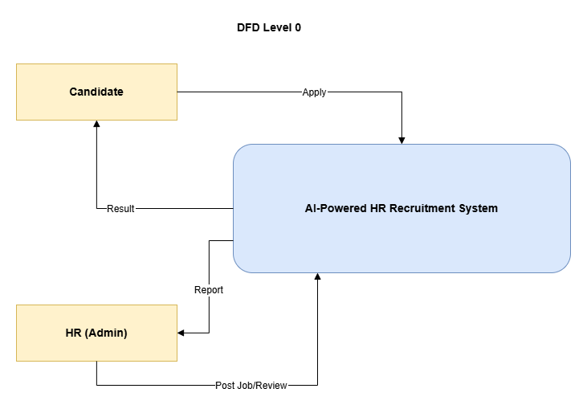
Figure 1 DFD level 0
The DFD Level 0 provides a high-level view of the AI-Powered HR Recruitment System as a single process interacting with two external entities: the Candidate and HR (Admin). The Candidate applies through the system and receives results such as application status, shortlisting, and interview outcomes, while HR posts jobs, reviews generated reports and makes the final hiring decision. The system performs automated processing including CV parsing, AI-based matching, AI interview reporting, and sends the appropriate outcomes back to both the Candidate and HR.
Level 1 DFD
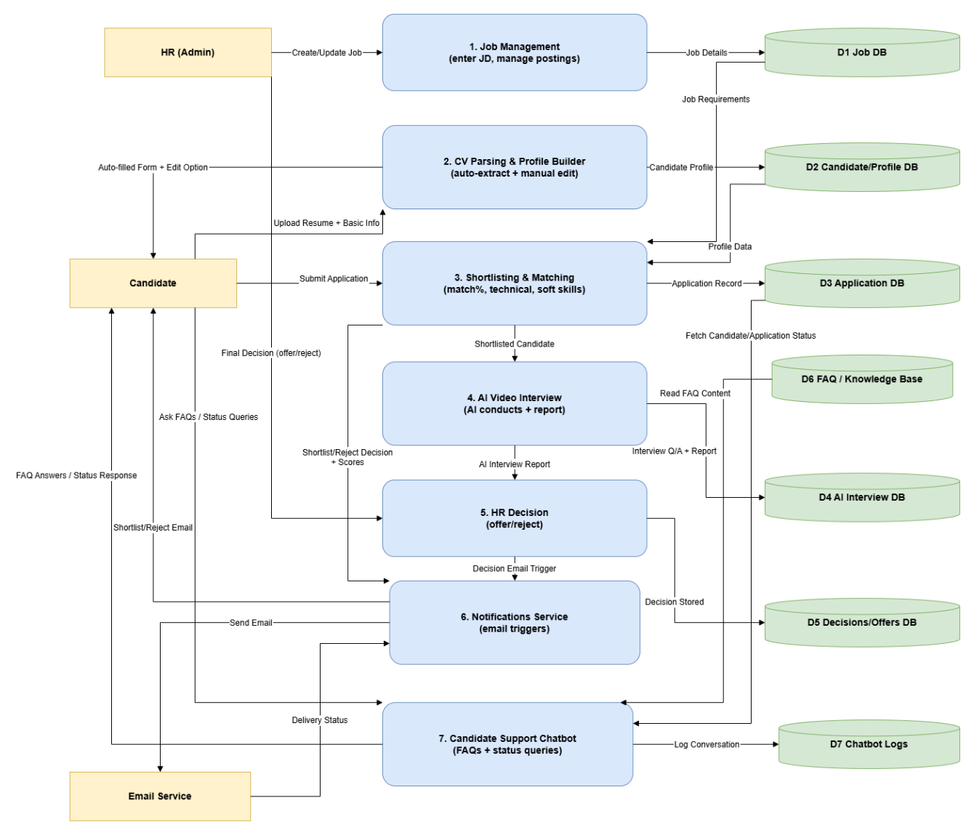
Figure 2 DFD level 1
The DFD Level 1 illustrates the internal workflow of the AI-Powered HR Recruitment System by decomposing it into major functional processes. HR manages job postings through the Job Management module, while candidates upload resumes that are parsed automatically to build candidate profiles with options for manual editing. The system performs AI-based shortlisting and matching using technical and soft skill analysis, followed by an AI-conducted video interview that generates detailed reports. HR reviews these reports to make the final offer or rejection decision, after which the Notifications Service automatically sends emails to candidates. Additionally, the Candidate Support Chatbot handles FAQs and application status queries, with all relevant data stored and retrieved from dedicated databases to ensure smooth system operation.

3.3.2 Use Case Diagrams
Job Management Use Case Diagram
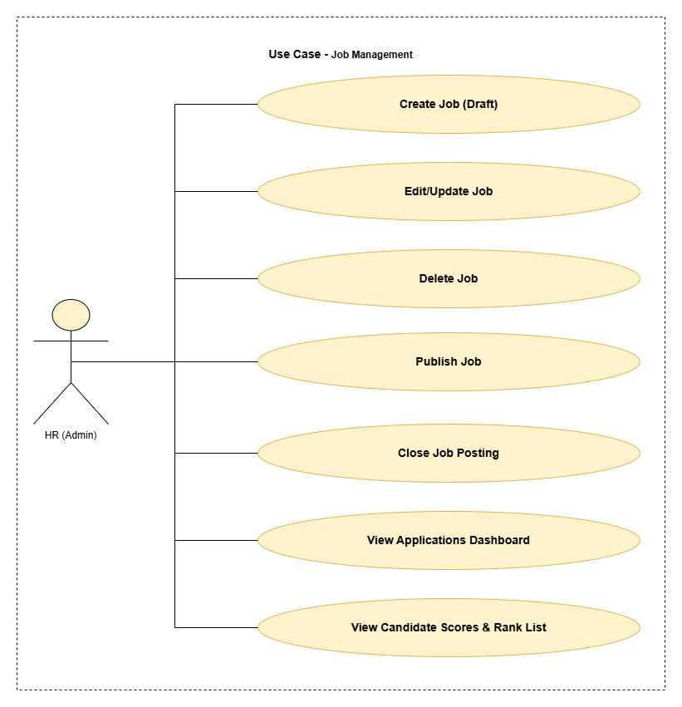
Figure 3 Use Case Diagram Job Management
The Job Management use case describes the responsibilities of the HR (Admin) within the recruitment system. HR can create job postings in draft form, edit or update existing jobs, delete jobs when required, and publish job postings for candidates to apply. HR also has the ability to close job postings once hiring is completed. In addition, HR can view the applications dashboard to monitor incoming applications and review candidate scores along with the ranked list generated by the system to support informed hiring decisions.

Candidate Application Use Case Diagram
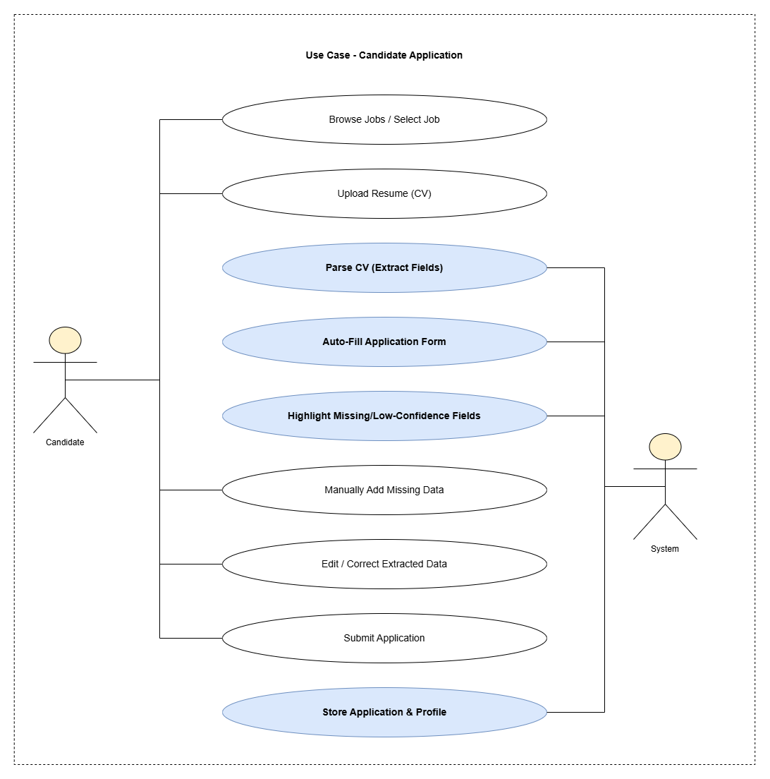
Figure 4 Use Case Diagram Candidate Application
The Candidate Application use case describes how a candidate applies for a job using the system. The candidate browses available jobs, selects a suitable position, and uploads a resume. The system then parses the resume to extract relevant information and automatically fills the application form while highlighting any missing or low confidence fields. The candidate can manually add missing information or edit incorrect extracted data before submitting the application. Once submitted, the system stores the application and candidate profile for further processing in the recruitment workflow.

Shortlisting Email Use Case Diagram
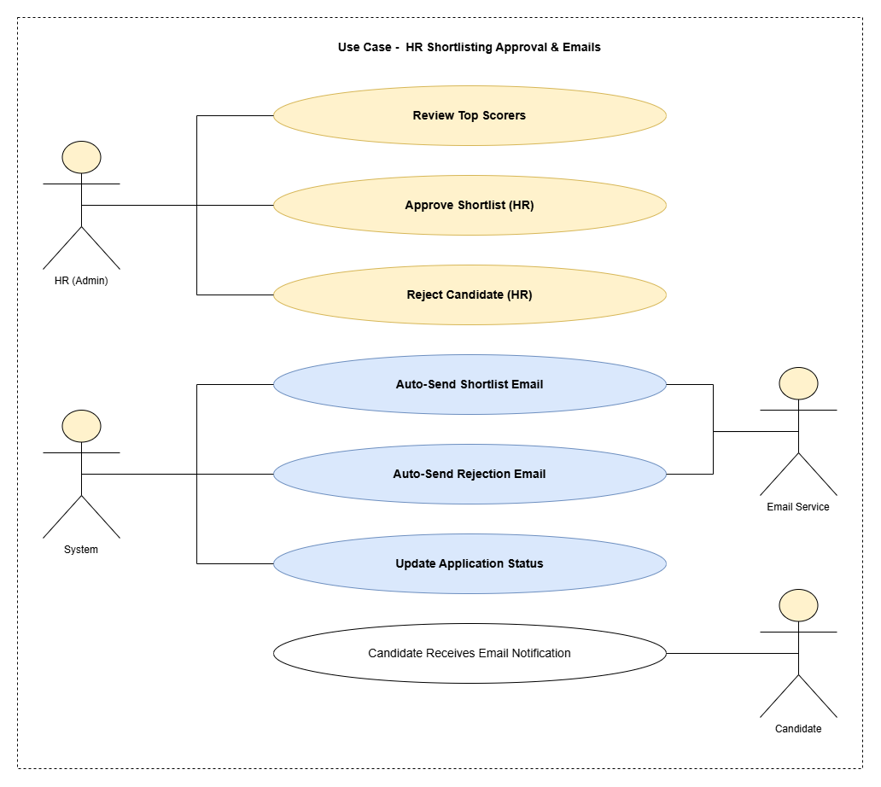
Figure 5 Use Case Diagram HR Shortlisting Approval and Emails
The HR Shortlisting Approval and Emails use case describes how shortlisted candidates are finalized and informed. HR reviews the top scoring candidates generated by the system and decides whether to approve or reject each candidate. Once HR makes a decision, the system automatically updates the application status and sends the appropriate email through the email service. Shortlisted candidates receive a shortlisting email, while rejected candidates receive a rejection email, ensuring timely and consistent communication without manual intervention.

AI Matching and Ranking Use Case Diagram
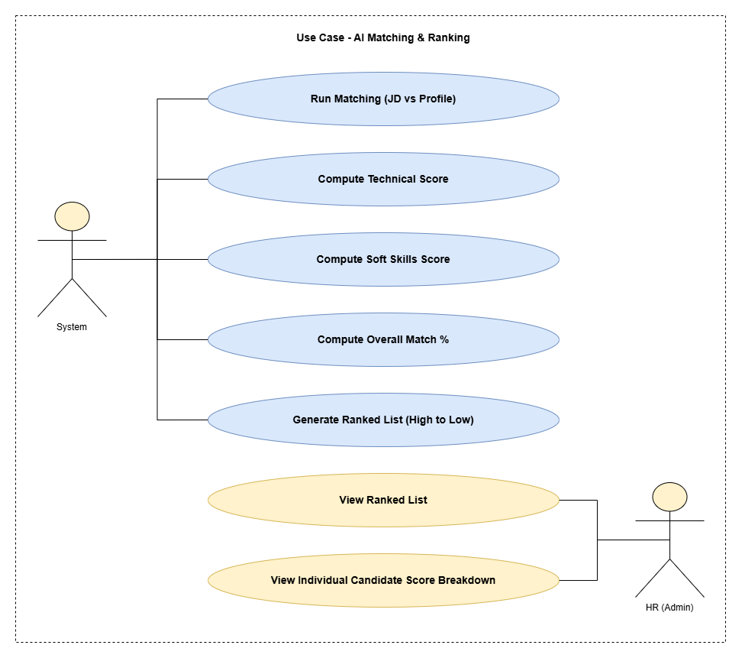
Figure 6 Use Case Diagram AI Matching and Ranking
The AI Matching and Ranking use case describes how the system automatically evaluates candidates against job requirements. The system compares the job description with candidate profiles, calculates technical and soft skill scores, and then computes an overall match percentage. Based on these results, the system generates a ranked list of candidates from highest to lowest match. HR can view this ranked list and access detailed score breakdowns for individual candidates to support informed shortlisting and decision making.

AI Video Interview Use Case Diagram
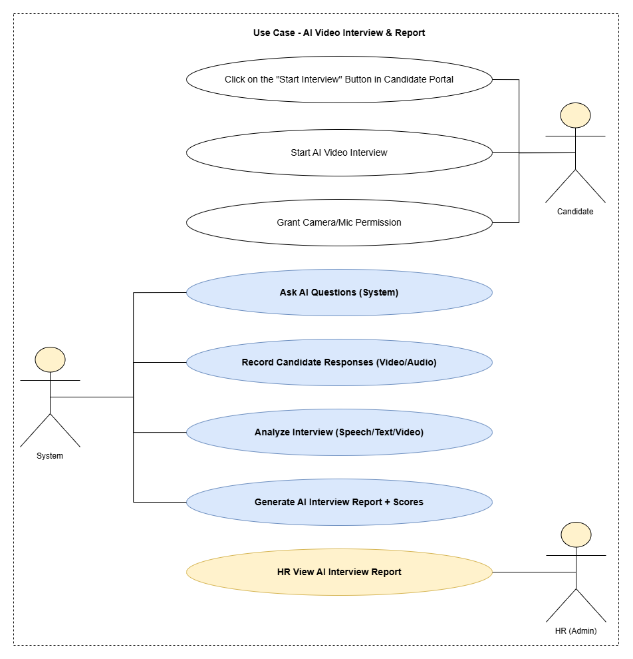
Figure 7 Use Case Diagram AI Video Interview and Report
The AI Video Interview and Report use case explains how interviews are conducted within the system without human intervention. The candidate starts the interview from the candidate portal and grants camera and microphone access. The system then asks interview questions, records the candidate’s audio and video responses, and analyzes the interview based on speech, text, and video data. After completing the analysis, the system generates an interview report along with evaluation scores. HR can then view this interview report to support the final hiring decision.

Chatbot Use Case Diagram
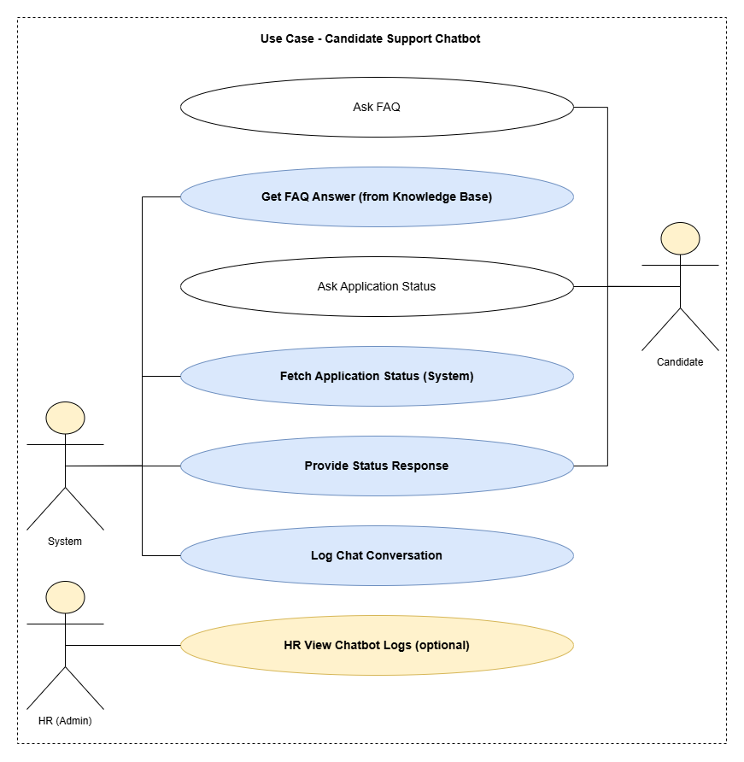
Figure 8 Use Case Diagram Candidate Support Chatbot
The Candidate Support Chatbot use case describes how candidates interact with the system to obtain information and track their application progress. Candidates can ask frequently asked questions or inquire about their application status through the chatbot. The system retrieves answers from the knowledge base or fetches the current application status and provides an appropriate response to the candidate. All chatbot interactions are logged for record keeping, and HR may optionally view these logs to monitor candidate queries and system responses.

Final Decision Use Case Diagram
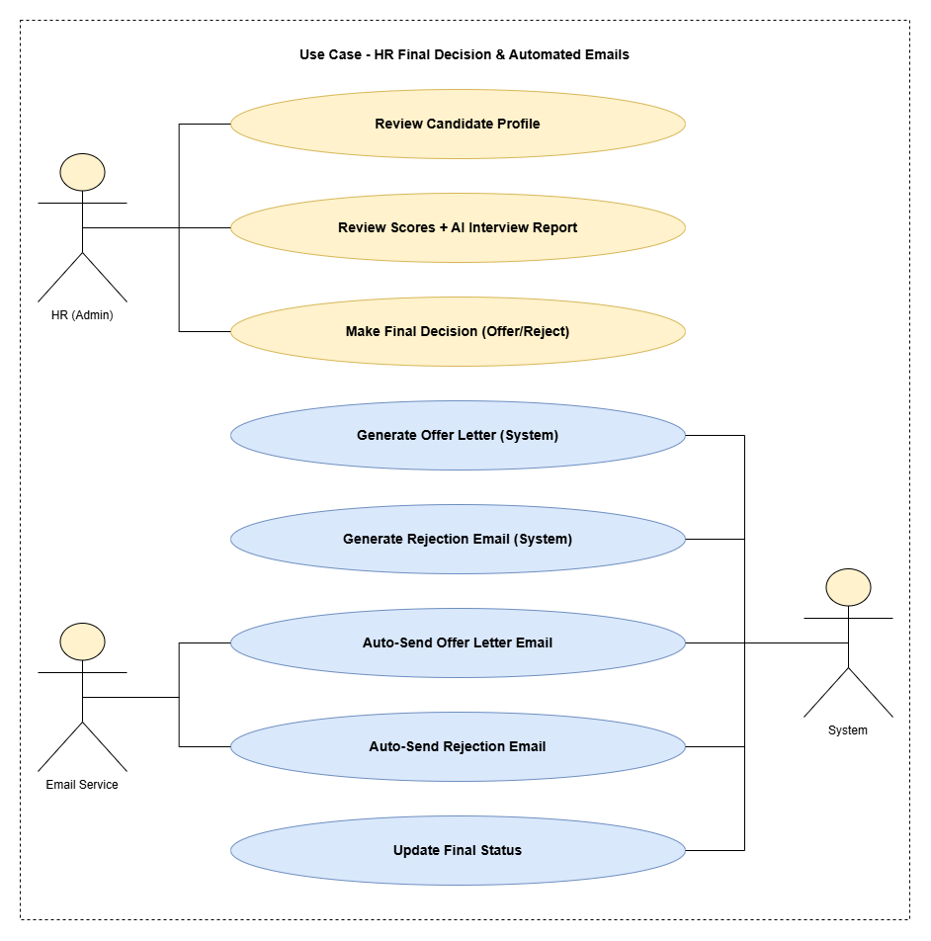
Figure 9 Use Case Diagram HR Final Decision and Email Automation
The HR Final Decision and Automated Emails use case describes the final stage of the recruitment process. HR reviews the complete candidate profile along with evaluation scores and the AI interview report, and then makes the final decision to offer or reject the candidate. Based on this decision, the system automatically generates the appropriate offer letter or rejection email and sends it through the email service. The system also updates the final application status to ensure accurate records and consistent communication with the candidate.

3.3.3 ER Diagram
Complete Entity-Relationship Diagram
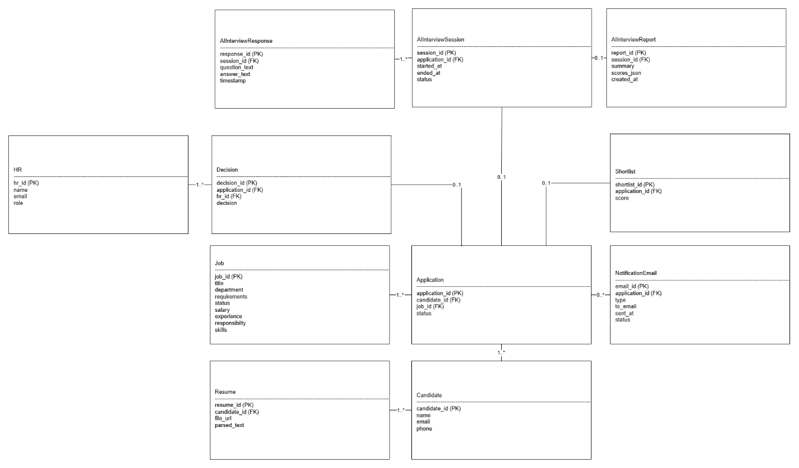
Figure 10 ERD
The ERD represents the complete data structure of the AI Powered HR Recruitment System and shows how recruitment related entities are connected. A candidate can upload one or more resumes and submit applications for different jobs. Each application is linked to a specific job and candidate and may be shortlisted based on scoring. Shortlisted applications can proceed to an interview session, where multiple interview responses are recorded and an interview report may be generated. HR reviews applications and interview outcomes to make a final decision, which is stored along with the related application. The system also manages notification emails sent to candidates regarding shortlisting, rejection, or offers. This ERD defines how data flows across recruitment, evaluation, decision making, and communication processes within the system.

3.3.4 Sequence and Activity Diagrams
Sequence Diagram Job Management
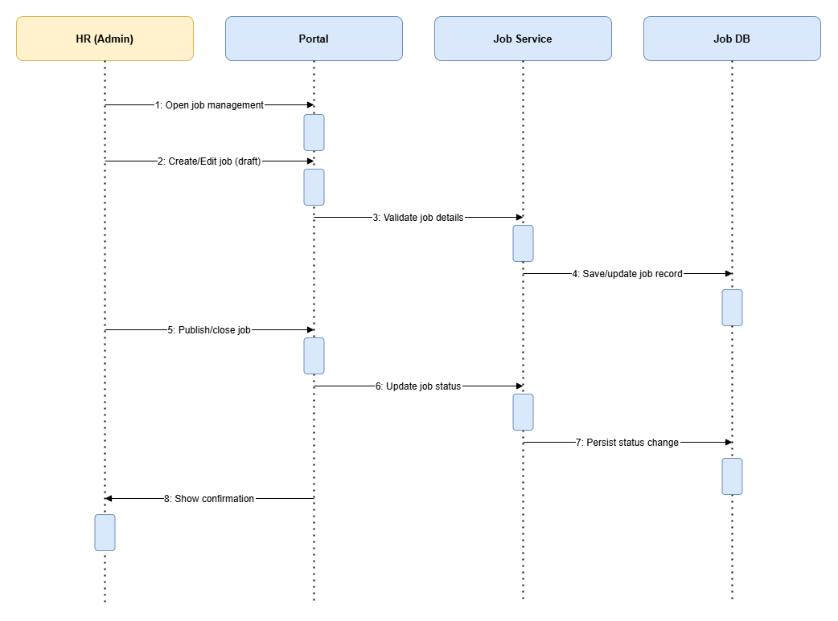
Figure 11 Sequence Diagram Job Management
This sequence diagram illustrates the job management process performed by HR through the system. HR accesses the job management module via the portal and creates or edits a job in draft form. The portal forwards the job details to the job service for validation, after which the job record is saved or updated in the job database. When HR publishes or closes a job, the portal requests the job service to update the job status, which is then persisted in the database. Finally, the system confirms the successful action and displays a confirmation message to HR.

Sequence Diagram Candidate Application
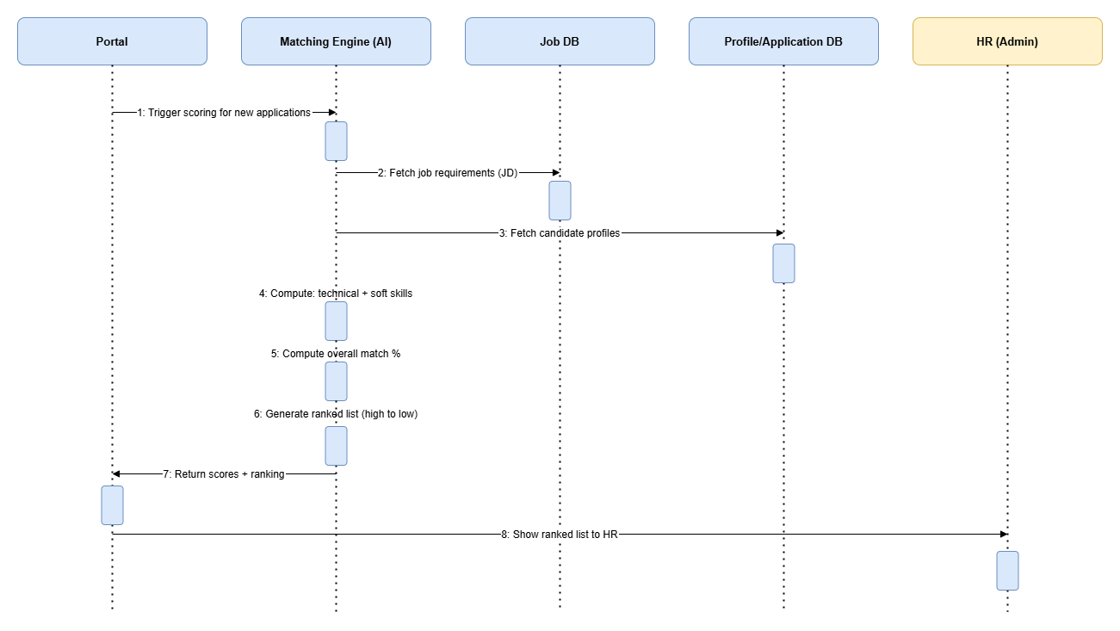
Figure 12 Sequence Diagram Candidate Application
This sequence diagram describes the AI-based matching and ranking process in the recruitment system. The portal triggers the scoring process when new applications are received and sends a request to the AI matching engine. The matching engine retrieves job requirements from the job database and candidate profiles from the profile and application database. It then computes technical and soft skill scores, calculates the overall match percentage, and generates a ranked list of candidates from highest to lowest. The computed scores and rankings are returned to the portal, which presents the ranked list to HR for review.

Sequence Diagram AI Matching and Ranking
Figure 13 Sequence Diagram AI Matching and Ranking
This sequence diagram shows how AI-based candidate matching and ranking is performed in the system. When new applications are submitted, the portal triggers the scoring process by sending a request to the AI matching engine. The matching engine retrieves job requirements from the job database and candidate profiles from the profile and application database. It then calculates technical skill scores, soft skill scores, and the overall match percentage for each candidate. Based on these results, the system generates a ranked list from highest to lowest match and returns the scores and rankings to the portal, which then displays the ranked list to HR for review and shortlisting.

Sequence Diagram Shortlisting Approval Emails
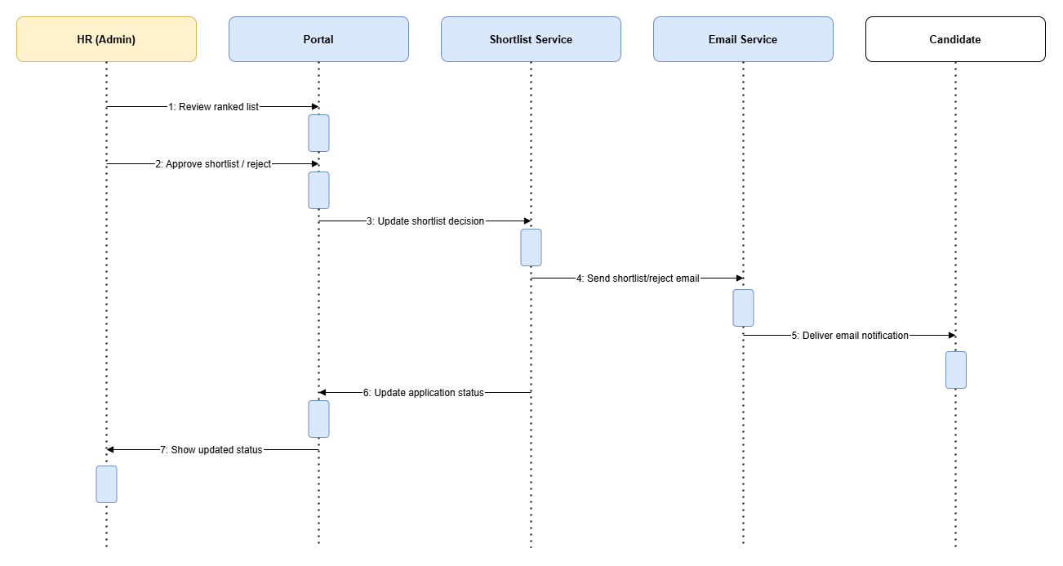
Figure 14 Sequence Diagram Shortlisting Approval Email
This sequence diagram explains the shortlisting and notification process in the recruitment system. HR reviews the ranked list of candidates through the portal and approves or rejects candidates based on the evaluation results. The portal sends the decision to the shortlist service, which triggers the email service to send the appropriate shortlist or rejection email to the candidate. At the same time, the system updates the application status and displays the updated status to HR, ensuring that both candidate communication and application records remain consistent.

Sequence Diagram AI Video Interview
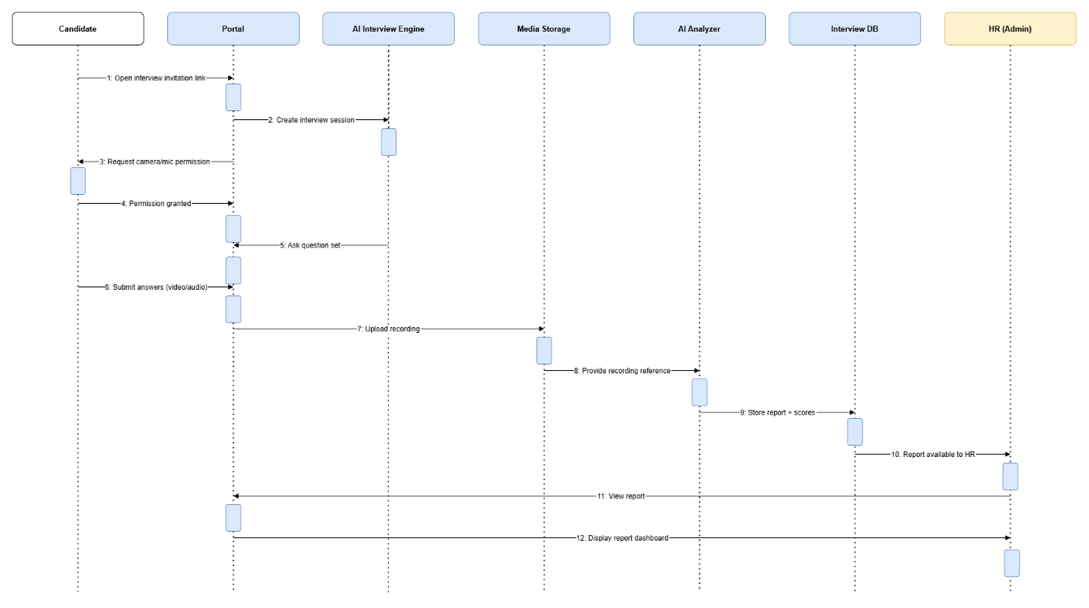
Figure 15 Sequence Diagram AI Video Interview
This sequence diagram illustrates the AI-based video interview process in the recruitment system. The candidate opens the interview invitation link through the portal, which creates an interview session with the AI interview engine. After camera and microphone permissions are granted, the AI engine asks interview questions and the candidate submits audio or video responses. The recorded responses are uploaded to media storage and then analyzed by the AI analyzer to generate interview scores and a detailed report. The interview report is stored in the interview database and made available to HR through the portal, where HR can view the report and assessment results for final evaluation.

Sequence Diagram HR Final Decision
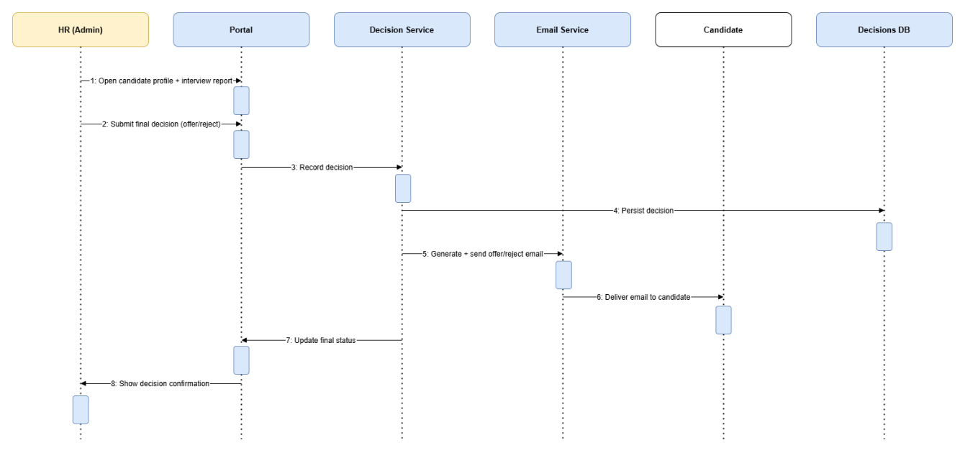
Figure 16 Sequence Diagram HR Final Decision
This sequence diagram represents the final decision process in the recruitment system. HR opens the candidate profile along with the interview report through the portal and submits the final decision to offer or reject the candidate. The decision service records and stores this decision in the decisions database. Based on the recorded decision, the system generates and sends the appropriate offer or rejection email through the email service, which is then delivered to the candidate. Finally, the system updates the final application status and displays a confirmation message to HR, completing the recruitment workflow.

Sequence Diagram Chatbot
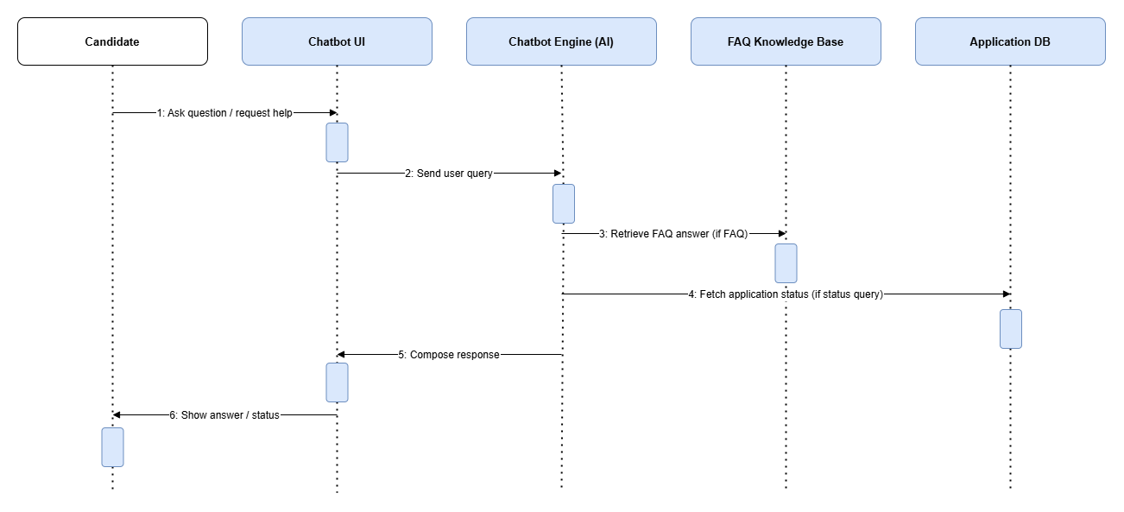
Figure 17 Sequence Diagram Chatbot
This sequence diagram explains how the candidate support chatbot handles user queries. The candidate asks a question or requests help through the chatbot interface, which forwards the query to the chatbot engine. If the query is related to frequently asked questions, the chatbot retrieves the answer from the FAQ knowledge base, and if it is related to application status, it fetches the required information from the application database. The chatbot engine then composes an appropriate response and sends it back through the chatbot interface, which displays the answer or status update to the candidate.

Complete Recruitment Workflow Activity
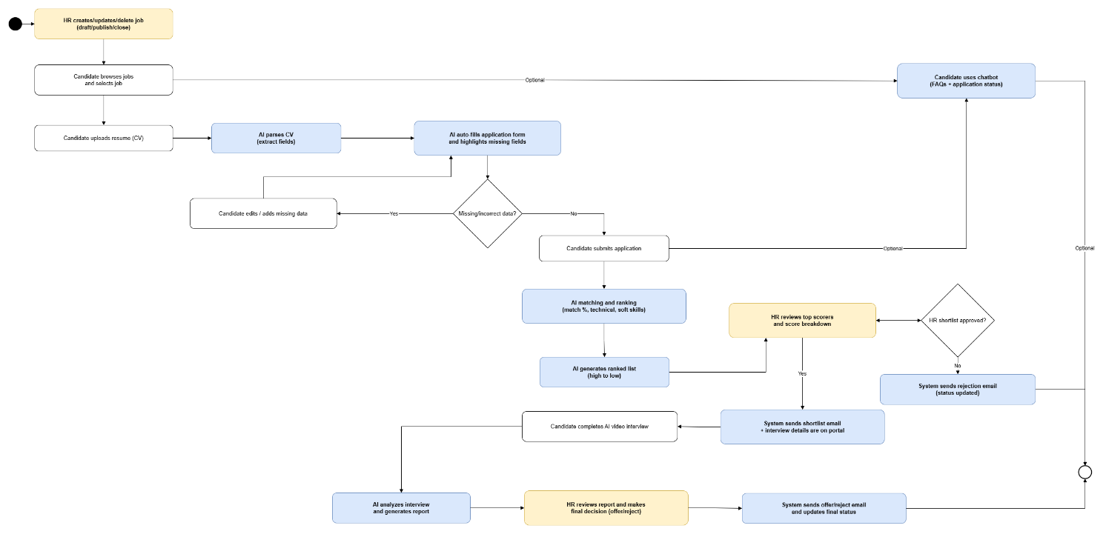
Figure 18 Activity Diagram
This activity diagram represents the complete workflow of the AI Powered HR Recruitment System. The process starts when HR creates, updates, or publishes a job, after which candidates browse jobs and upload their resumes. The system parses the CV, automatically fills the application form, and highlights missing or incorrect data that the candidate can edit before submitting the application. Once submitted, the system performs AI-based matching and ranking using technical and soft skill analysis and generates a ranked list. HR reviews top scorers and decides whether to shortlist or reject candidates, triggering automated emails accordingly. Shortlisted candidates complete an AI video interview, which is analyzed by the system to generate an interview report. HR then reviews the report and makes the final offer or rejection decision, after which the system sends the final email and updates the application status. Throughout the process, candidates may optionally interact with the chatbot for FAQs and application status queries.

3.4 External Interface Requirements
This part describes all interactions between the system and outside entities which are users, hardware, software systems and communication protocols. Detailed interface specifications make sure that the integration is smooth and user experiences are consistent.

3.4.1 User Interfaces
HR Dashboard Interface
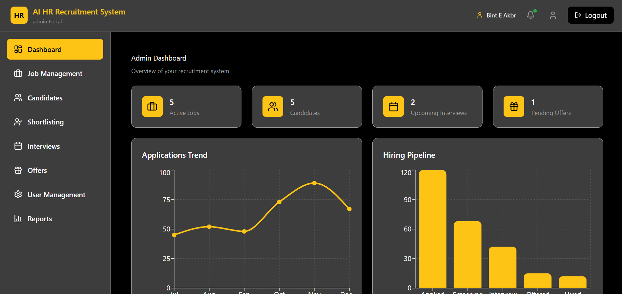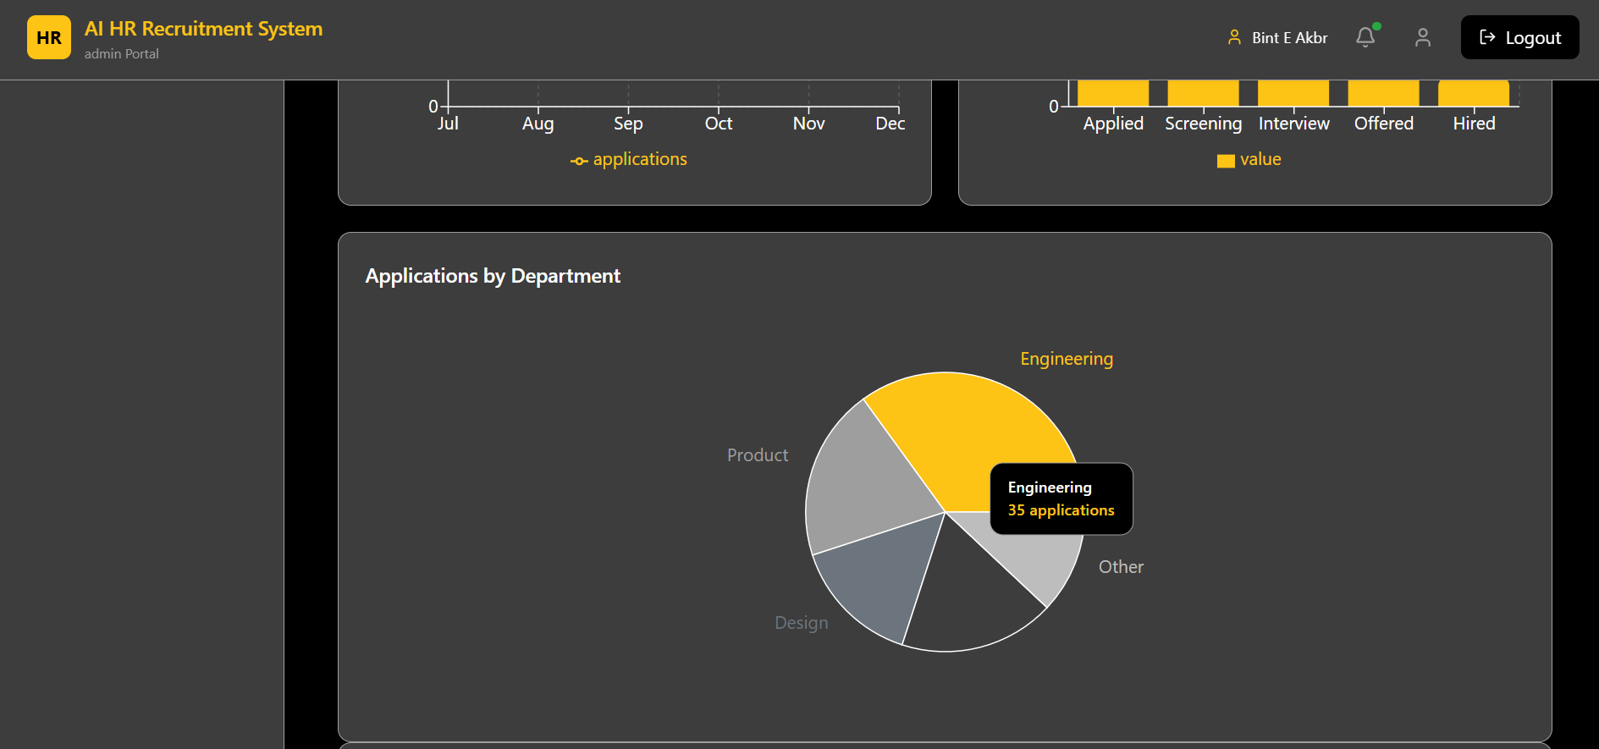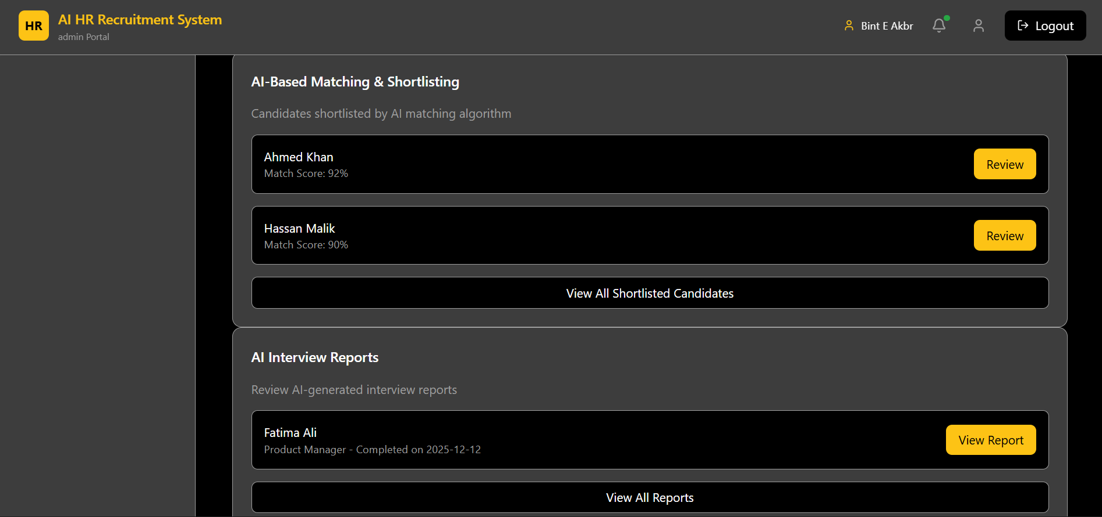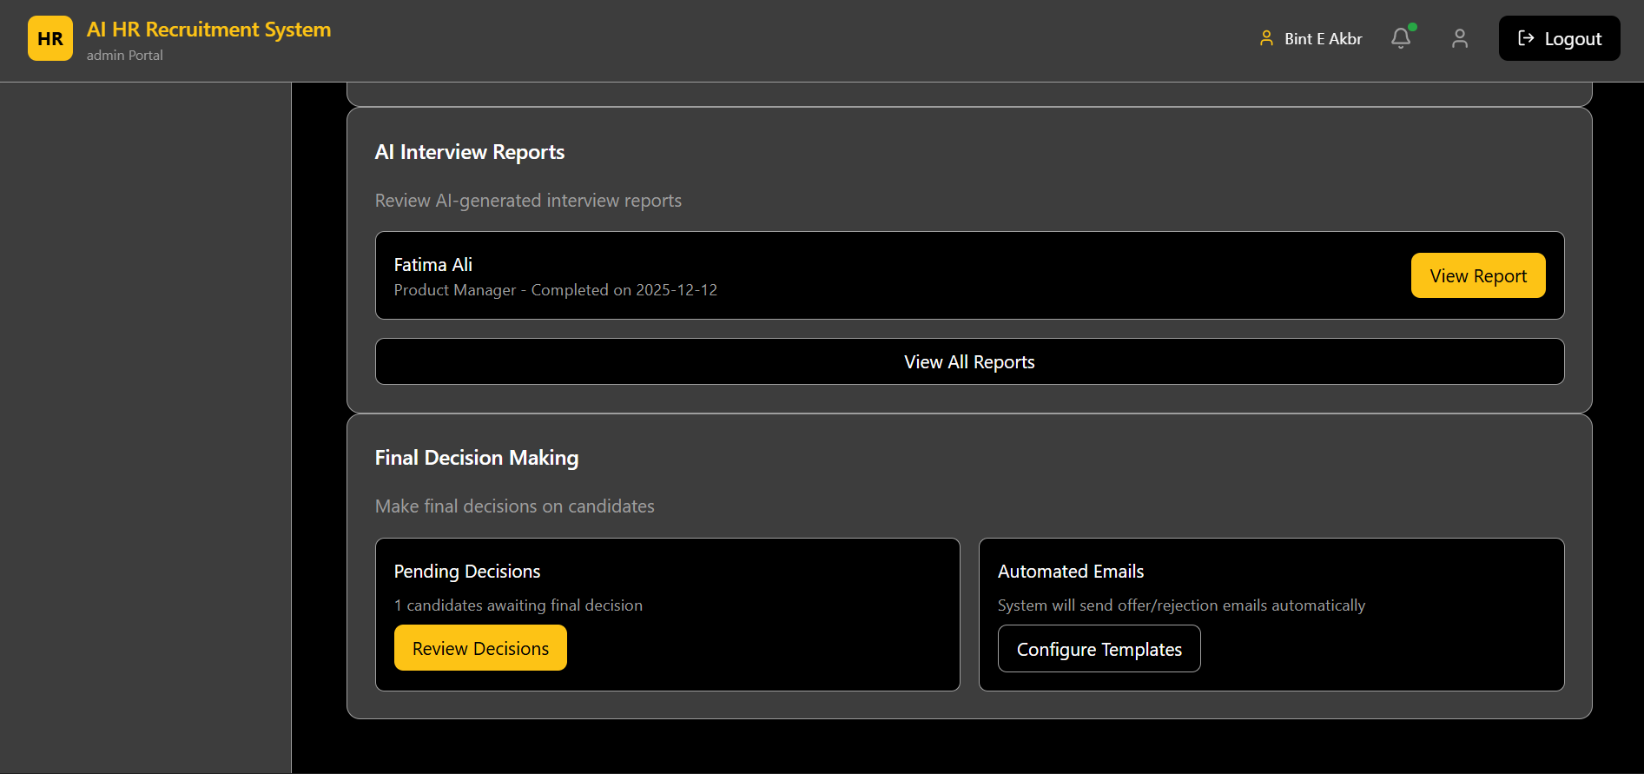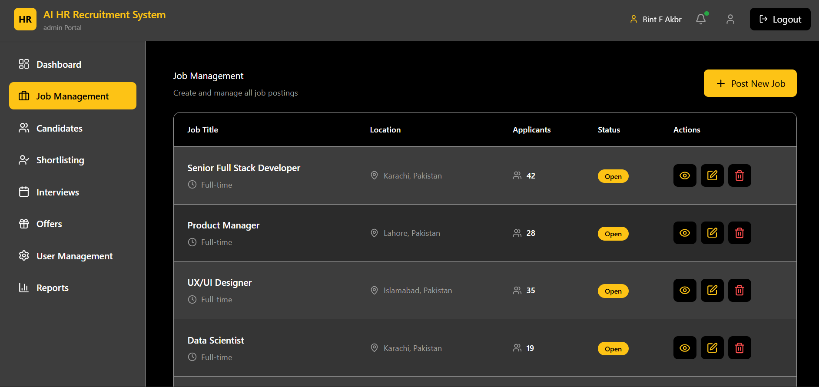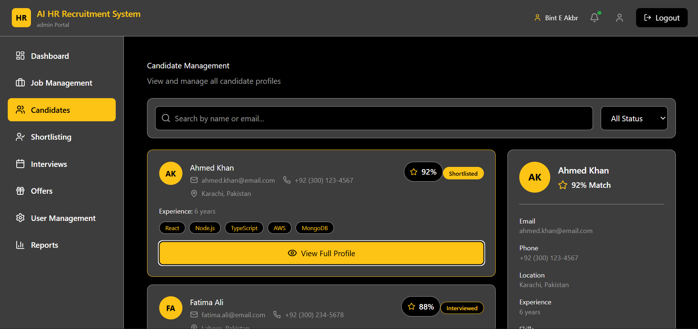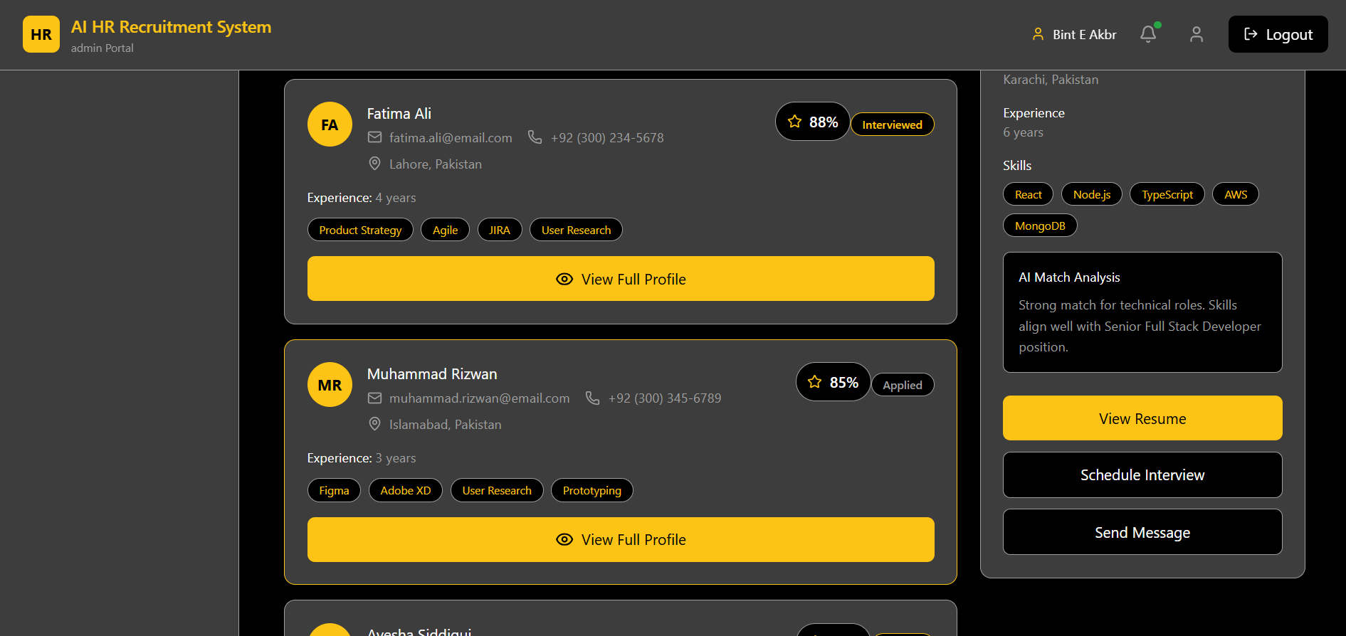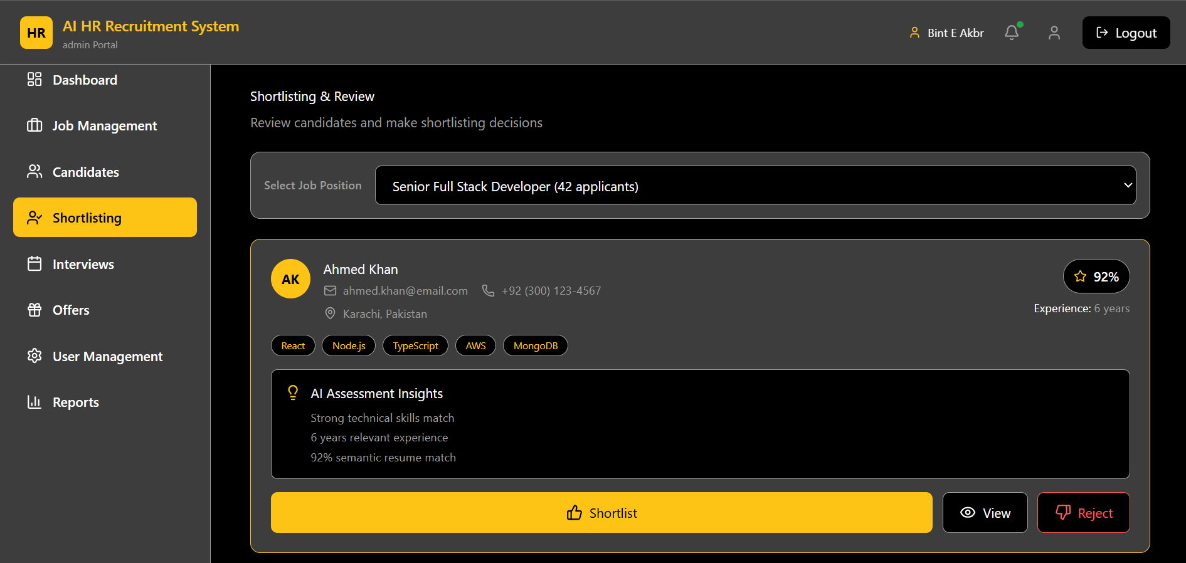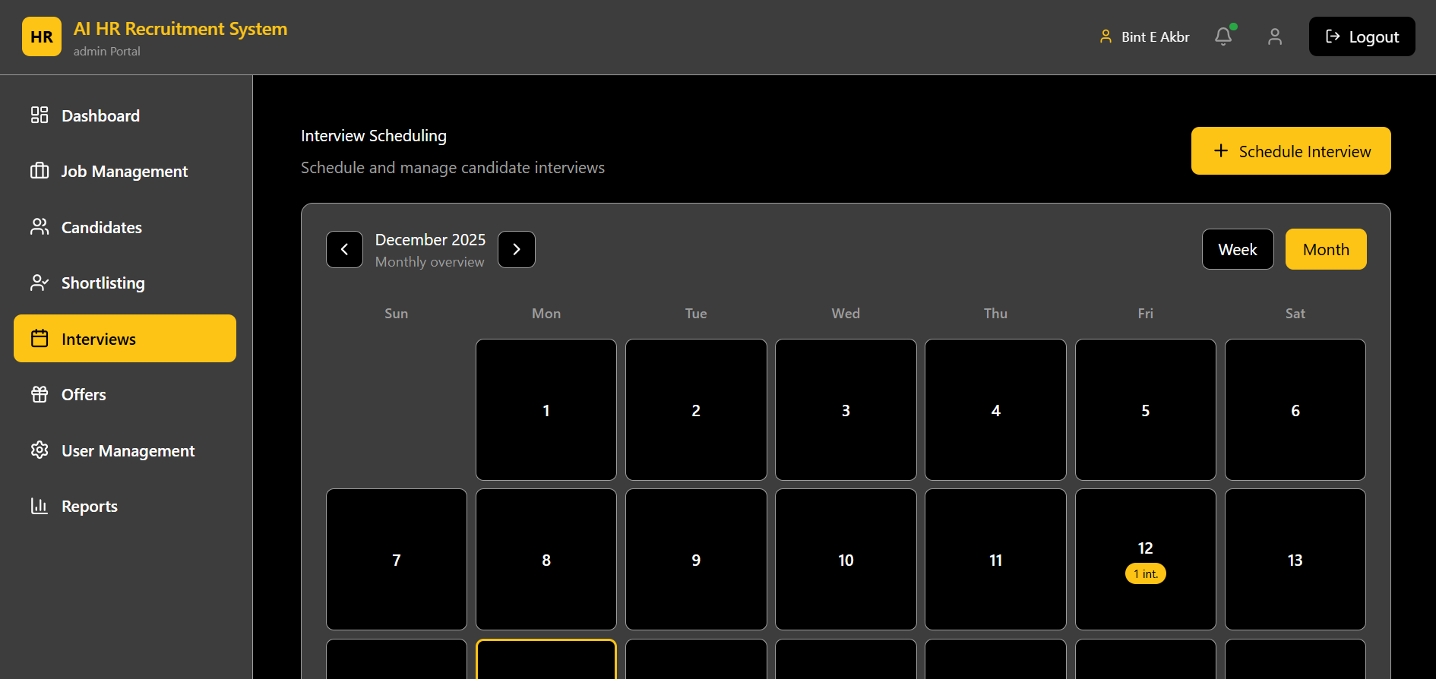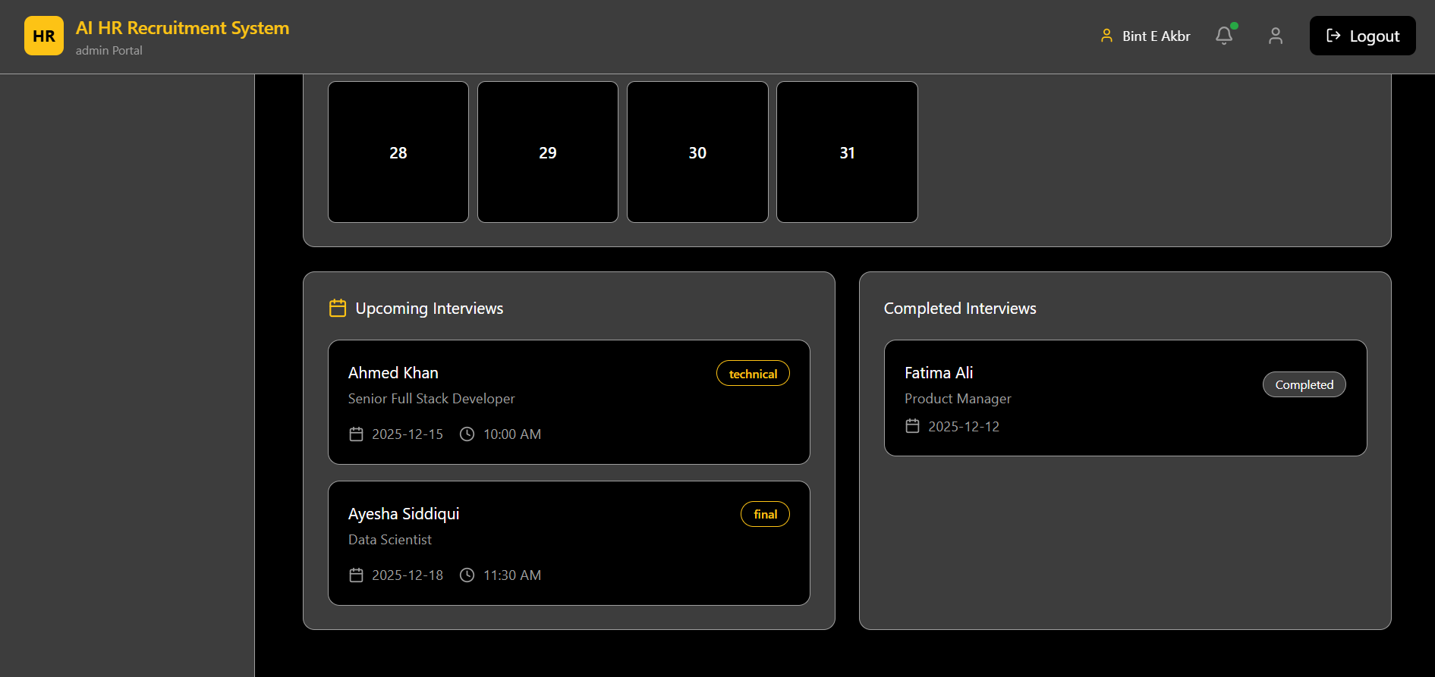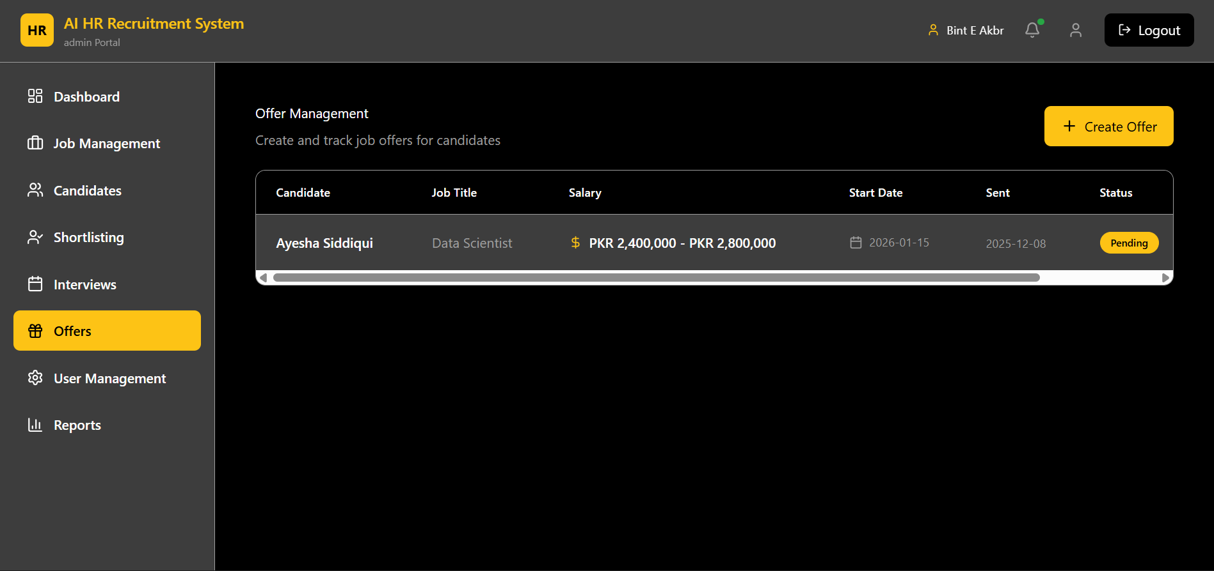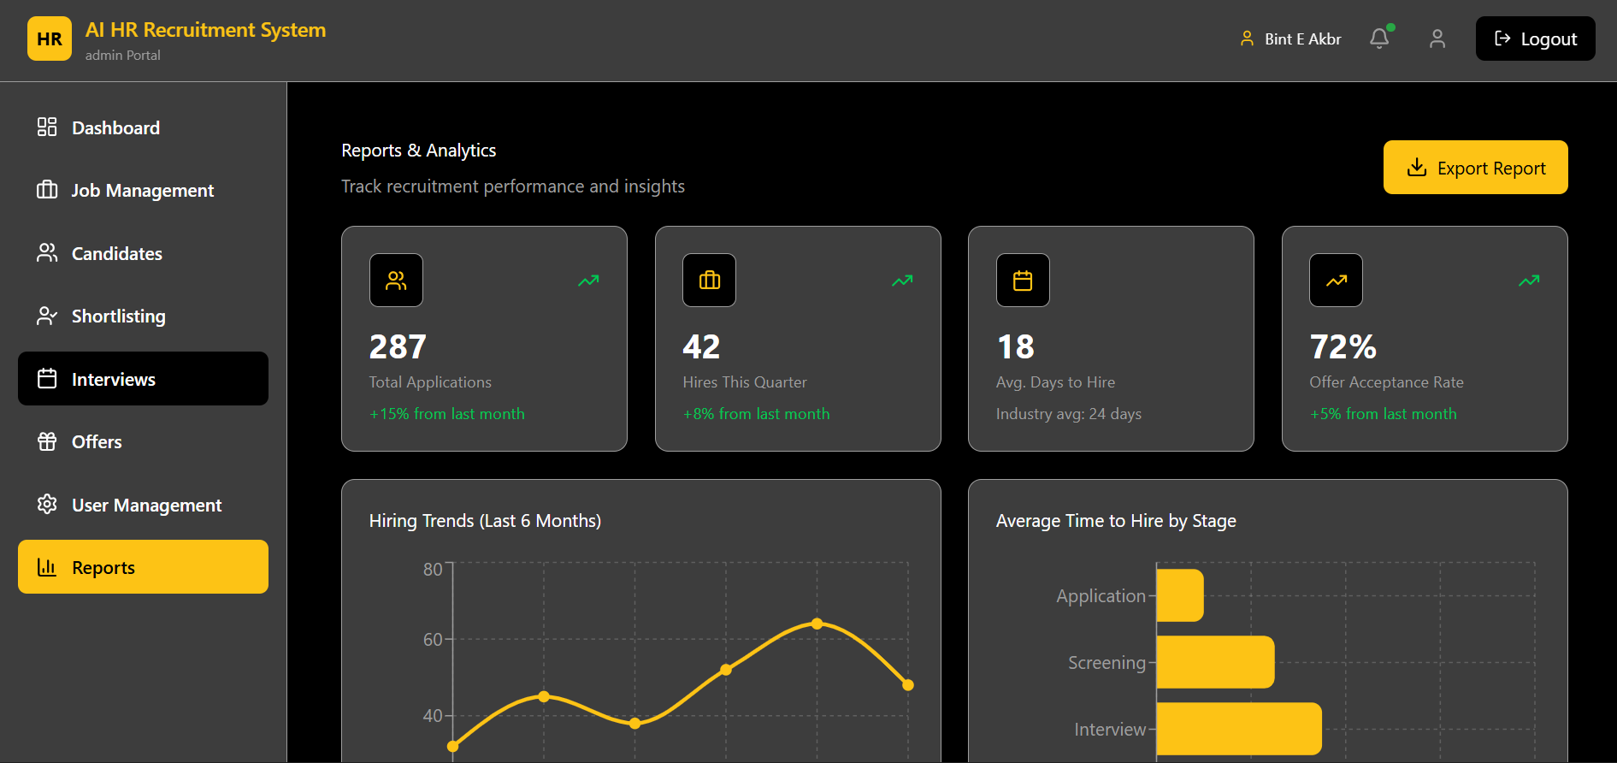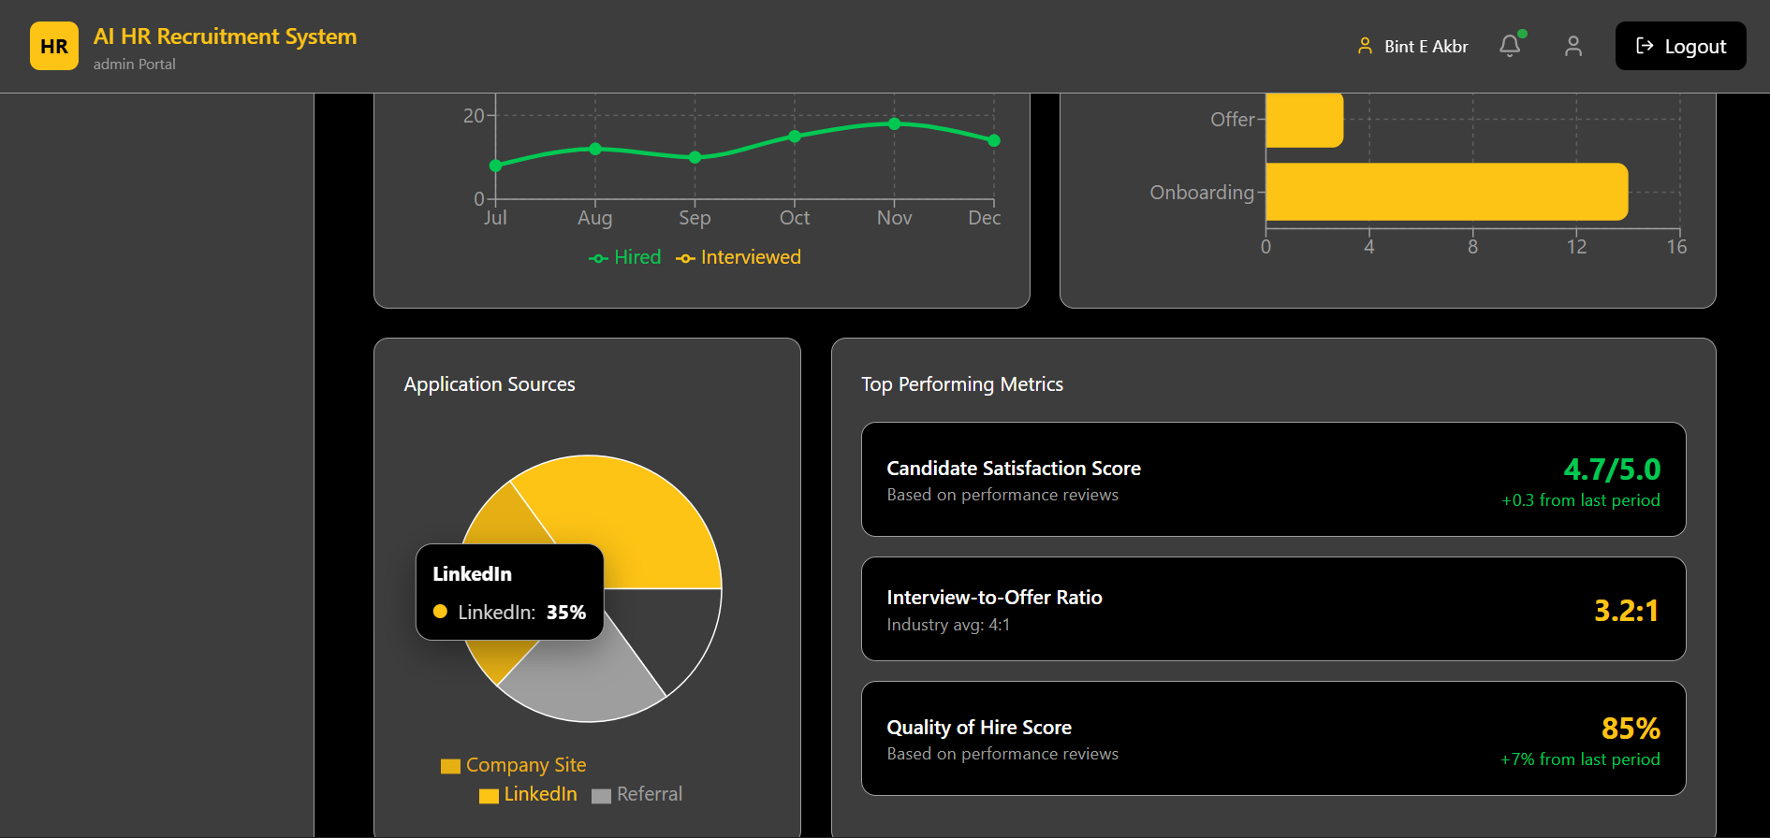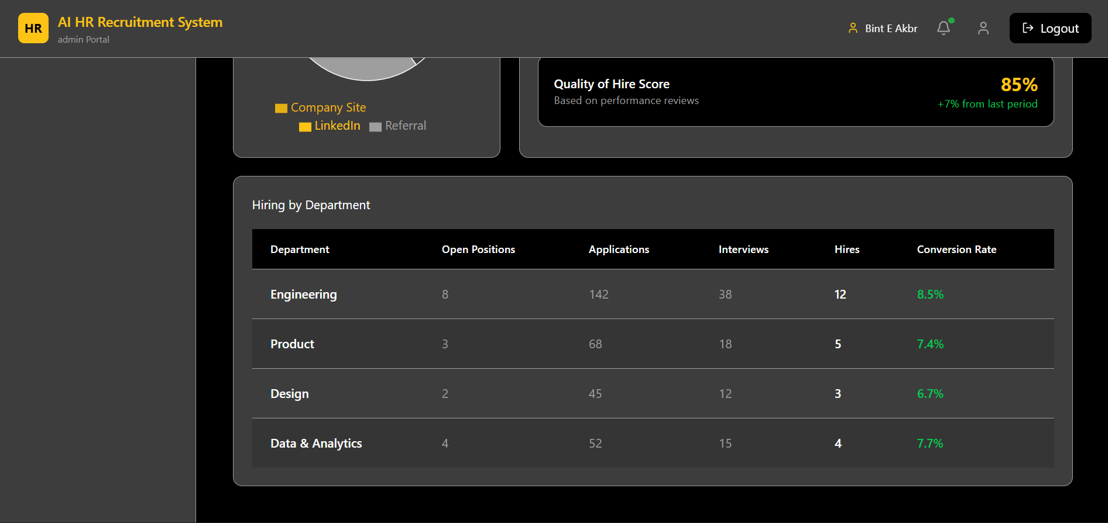
Candidate Portal Interface
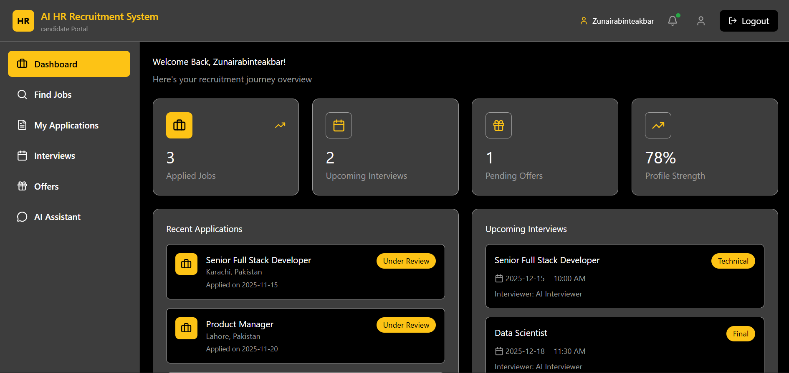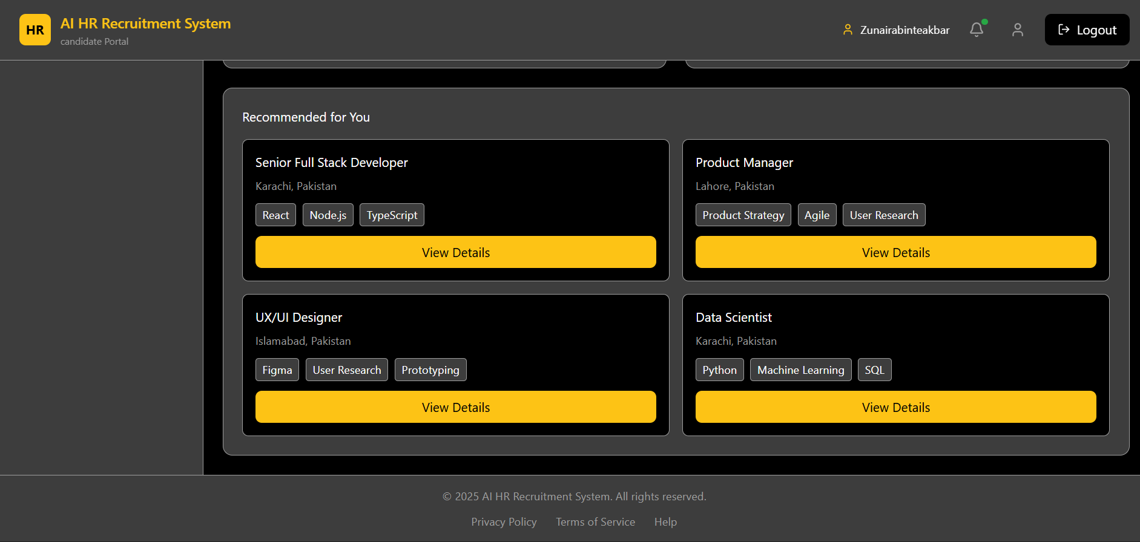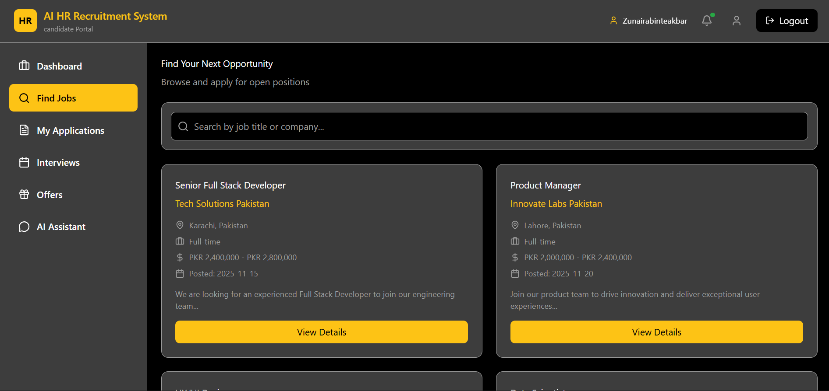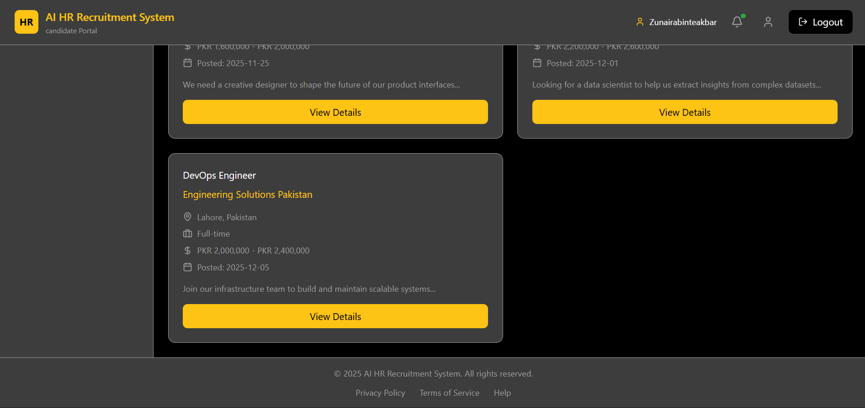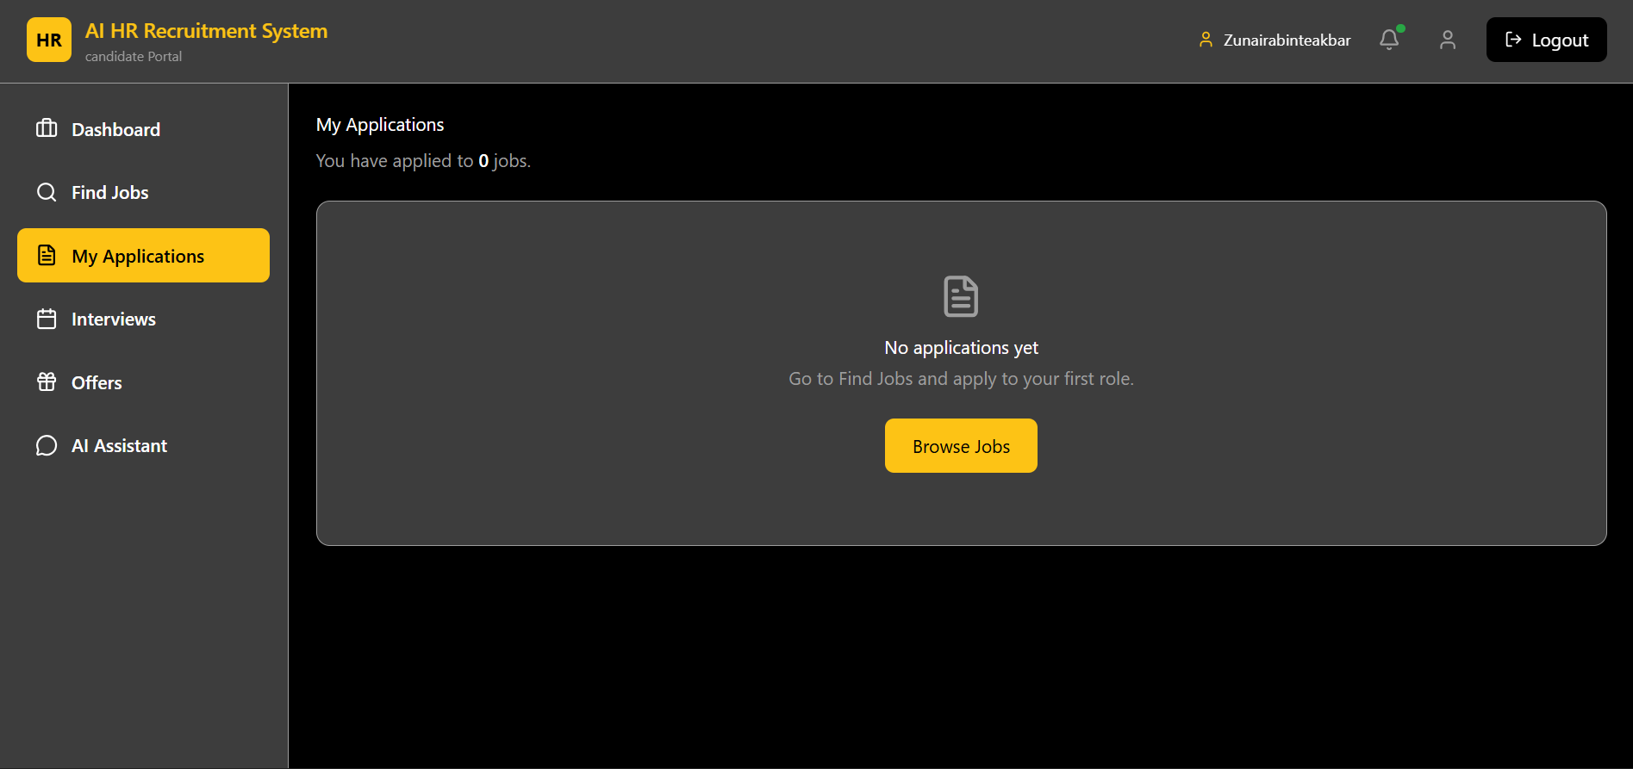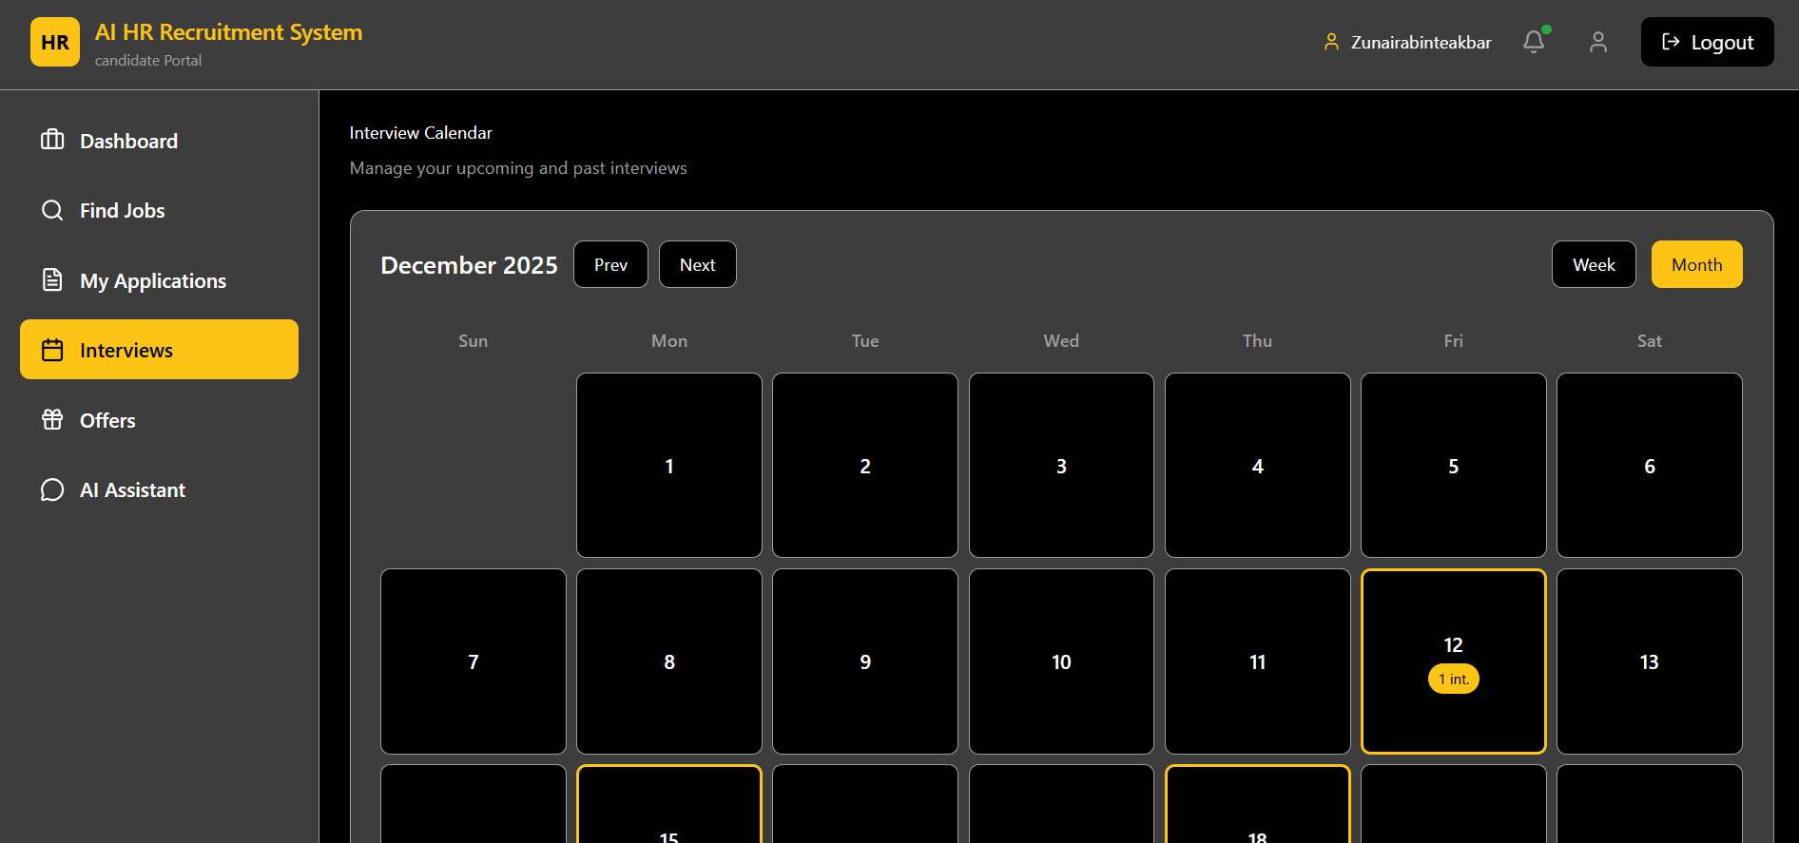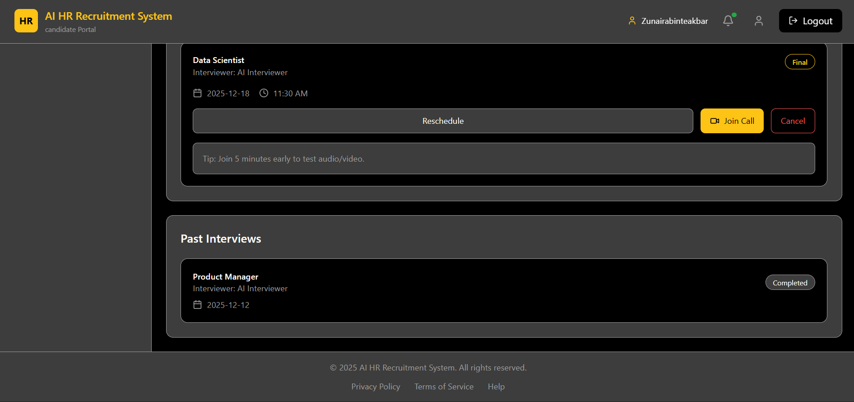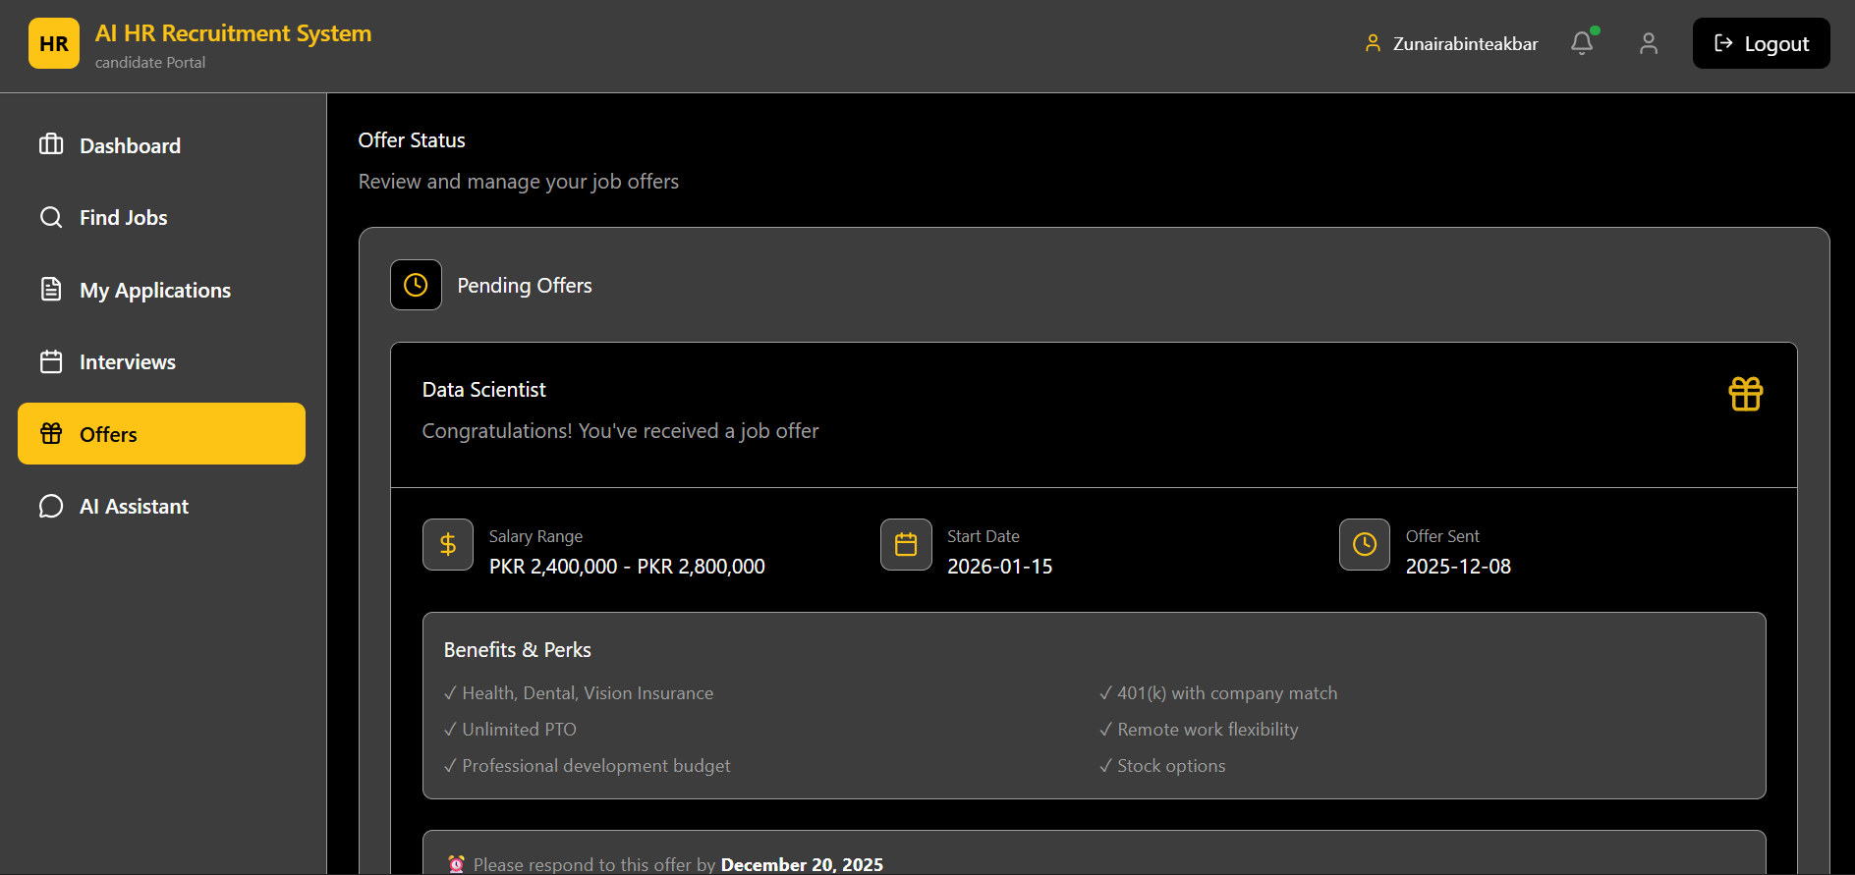
Chatbot Interface
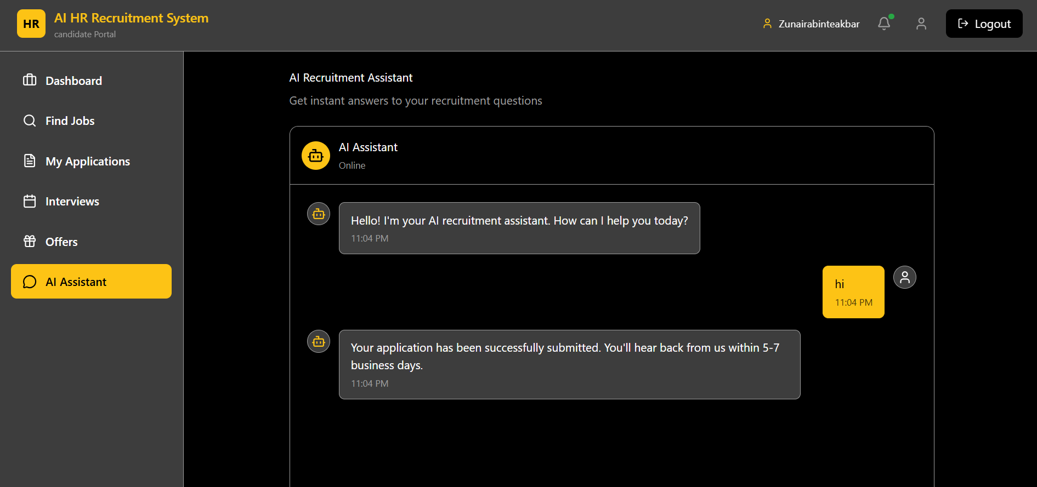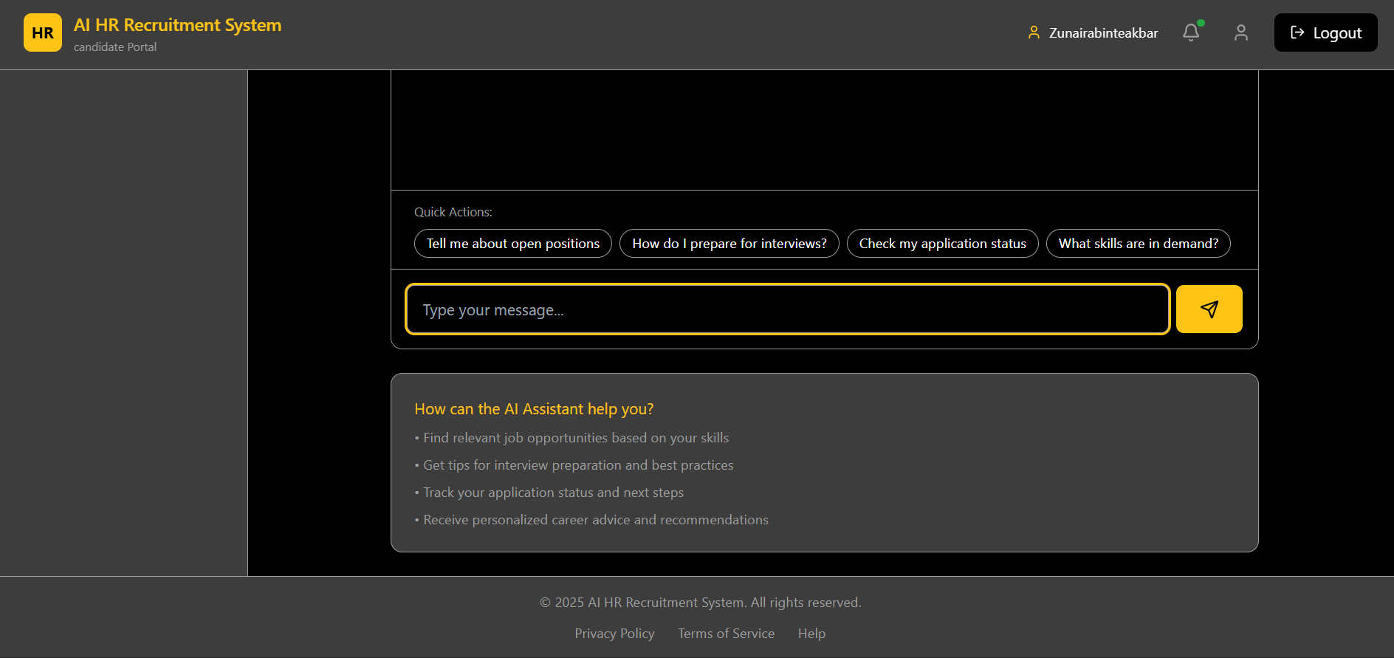

3.5 Constraints and Limitations
This part outlines the limitations that could potentially impact the design, development, and functioning of the AI Powered HR Recruitment System in real life. These limitations will aid in maintaining realistic expectations and will ensure that practical design decisions are made.
Cost and Academic Constraints
- The project is developed as an academic FYP with limited budget.
- Development resources are limited to a small team (two students), which restricts parallel development and extensive support.
- Testing is limited due to restricted access to real HR departments and real hiring cycles for long-duration validation.
Time Constraints
- The system has to be delivered within the specified academic period, which reduces the number of iterations and the depth of improvements that can be applied.
- Waiting for certain enhancements might occur if they are not necessary for the operating parts and the final exhibition.
Technological Constraints
- The degree of accuracy in resume parsing is subject to the variations in the structure, the way it is presented, and the quality of the content.
- The scores achieved in matching are based on the precision of job descriptions and the comprehensiveness of applicant profiles, so when there is missing or inconsistent information, the outcome may change.
- AI processing tasks like parsing and matching could take longer in the event that the local server resources are limited and several candidates apply simultaneously.
Infrastructure Constraints (Local Server Deployment)
- The implementation of the system will be done in a local server environment which limits scalability to a certain extent when compared to cloud infrastructure.
- Processing speed for image capture and matching using CV may be influenced by local server hardware limitations, particularly during peak usage times.
- The network availability and stability in the local environment might have a negative impact on the responsiveness of the portal and the reliability of integration.
Integration Constraints (Google Calendar and Gmail)
- The interview scheduling process revolves around the seamless integration of Google Calendar, which will dictate the availability and event creation.
- The automated communications work hand-in-hand with Gmail integration since this is the only medium for sending emails.
- All these integrations rely on several external factors such as the availability of the respective APIs, proper configurations, and access rights, which can complicate the setup and bring about failure situations.
Privacy and Ethical Constraints (Basic Controls)
- The system deals with confidential applicant information; therefore, privacy measures need to be applied by means of role-based access and restricted visibility.
- Before any artificial intelligence-powered interviews are carried out and video-recorded, the consent of the candidate needs to be obtained.
- As the project puts in place only basic privacy measures, it is possible that the advanced compliance with regulations will be restricted to the main requirements like consent, access control, and managing data in a controlled way.
Data Constraints (Real Dataset Usage)
- The real dataset implementation will necessitate and involve taking a lot of precautions with respect to confidentiality and access, which will be controlled throughout development and testing phases.
- The parsing and matching results with real resumes and job descriptions can be impacted by data quality issues and thus may need to be corrected manually.
Operational Constraints
- HR may need to manually check edge cases which can be anything from very odd resume formats, partially finished applications and vague job descriptions.
- It will be hard to maintain the long-term because the support after the project is limited and there will be the need for updates if the workflows change.
Mitigation Strategies
- Before submission, to correct the auto-filled fields and to add any missing information the candidates should be allowed.
- HR should be given the option of taking control over the shortlist, interview approval, and final decision making.
- Key recruitment actions should have clear audit records maintained.
- When the automation fails, the fallback handling such as manual scheduling and manual completion paths should be used.
- The design should be kept modular so that later on it will be easy to add improvements without going through the process of completely rebuilding the system.

3.6 Assumptions and Dependencies
In this part, the assumptions that were made throughout the analysis and design of the AI Powered HR Recruitment System are presented and the external dependencies that the system needs to work properly within the limits of the Final Year Project are pointed out.
Assumptions
- The access to the system will be through the latest web browsers on both desktop and mobile devices.
- Human resources users and candidates will have stable internet connection for the normal system usage.
- The system will be set up and then tested on a local server environment which is good for academic development and demonstration.
- The CV Analyzer will allow the reading of resumes in TXT, DOCX, and PDF formats.
- In Pakistan, there is no common fixed or standard resume format that is usually followed; hence the resumes can differ a lot in terms of layout, wording, and structure.
- The precision of resume parsing is thought to be based on the clarity of the information in the uploaded resume.
- The job descriptions given by HR users are expected to be sufficiently detailed (skills, experience, role description) for meaningful matching.
- Google Calendar and Gmail services will still be there to help with interview scheduling and automatic email communication.
- The HR users will rely on AI-generated scores and interview analysis for support in decision-making but will manually take the final hiring decisions.
- The HR users will assess the shortlisted candidates and review the interview reports before moving towards offers or rejections.
- The candidates will send their real resumes and will be able to review, fix, or fill in the missing application data that has been automatically collected when needed.
- The candidates will have basic computer skills so that they can upload their resumes, deal with forms, and communicate through the candidate portal and chatbot.
- The project will be done following the academic Final Year Project timeline.
- The system will be assessed by means of functional demonstrations and limited testing instead of long-term industrial deployment.
- The real datasets which will be used for testing will be small in size and tightly controlled because of privacy concerns.
Dependencies
- Google Calendar API for scheduling interviews and managing availability.
- Gmail or SMTP-based email services for automatic notifications, invitations for interviews, and offers, as well as rejections.
- Free software libraries for parsing resumes, matching them, and performing basic AI processing.
- Technologies for backend, frontend, and database that are compatible with the infrastructure of the local server.
- Web-based audio and video facilities provided for the AI-powered interview feature.
- Real, though limited, resumes and job descriptions will be available for testing and validation purposes.
- Skill keywords and matching criteria grounded on general recruitment practices instead of exclusive datasets.
- Student developer team will be always available.
- Academic supervisors' advice and feedback.

Chapter 4
Remaining Work and Timeline
In this part, we present the tasks that still need to be done in order to finish the AI Powered HR Recruitment System. The timeline of activities is based on an Incremental Model implemented with Scrum-based sprint planning. Every task is accompanied by its present situation, significance, and anticipated finalization schedule.

Remaining Work Plan (Sprint-Based Timeline)
Table 1 Work Plan
Task ID | Task Description | Related Increment | Current Status | Expected Completion
RW-01 | Complete remaining work of existing two core modules (UI finalization, validations, edge cases, data consistency) | Increment 1 & 2 | In Progress (Interfaces ~80%) | 25-02-2026
RW-02 | Improve CV Analyzer accuracy on Pakistani resume dataset (TXT, DOCX, PDF formats) | Increment 2 | In Progress (Accuracy ~70%) | 05-03-2026
RW-03 | Complete AI Interview Module debugging and scoring stabilization | Increment 3 | In Progress (Module ~70%) | 10-03-2026
RW-04 | Implement AI Chatbot module (UI, FAQs, application status queries, guidance) | Increment 2 | Pending | 05-03-2026
RW-05 | Implement Interview Scheduling module with Google Calendar and Gmail integration | Increment 2 | Pending | 15-03-2026
RW-06 | Integrate full end-to-end recruitment workflow (Job → Application → Matching → Interview → Decision) | Increment 3 | Pending | 31-03-2026
RW-07 | System stabilization and bug fixing after integration | Increment 3 | Pending | 10-04-2026
RW-08 | Functional testing of all modules (HR, Candidate, Chatbot, Scheduling, Interview) | Increment 4 | Pending | 05-04-2026
RW-09 | Integration testing and end-to-end demo validation | Increment 4 | Pending | 15-04-2026
RW-10 | Complete SRS documentation (remaining sections, alignment with implementation) | Increment 4 | In Progress (SRS ~80%) | 31-03-2026
RW-11 | Add diagrams and screenshots (DFD, UML, Activity, UI evidence) | Increment 4 | Pending | 20-04-2026
RW-12 | Final report writing and presentation preparation | Increment 4 | Pending | 30-04-2026

Scrum-Based Milestones Summary
Table 2 Milestones Summary
Milestone | Description | Target Date
Milestone 1 | Existing core modules completed to 100% | 25-02-2026
Milestone 2 | CV Analyzer accuracy improved for Pakistani dataset | 05-03-2026
Milestone 3 | Chatbot module functional | 05-03-2026
Milestone 4 | Interview scheduling module functional | 15-03-2026
Milestone 5 | End-to-end workflow fully integrated | 31-03-2026
Milestone 6 | Testing and demo validation completed | 15-04-2026
Milestone 7 | Final SRS, report, and presentation ready | 30-04-2026

Development Approach Alignment
- The work is carried out in 2-week Scrum sprints.
- Every sprint consists of planning, development, testing, and review.
- Progressive delivery of increments is done to make sure that working modules are available at each stage.
- The emphasis is on functional completeness, correctness, and academic evaluation readiness rather than large-scale production deployment.

References
[1] A. Kumar et al., “A Deep Learning Approach for Resume Parsing,” IEEE Access, 2021.
[2] Y. Zhang and H. Liu, “Hybrid OCR-NLP Pipeline for Structured Extraction from Scanned Resumes,” Pattern Recognition Letters, 2022.
[3] R. Singh et al., “BERT-Based Information Extraction from Unstructured CVs,” Information Processing and Management, 2023.
[4] J. Liu et al., “Semantic Matching of Job Descriptions and Resumes Using Transformer Embeddings,” ACM Transactions on Information Systems, 2020.
[5] K. Patel and S. Sharma, “Context-Aware Skill Alignment via Sentence-BERT,” Expert Systems with Applications, 2021.
[6] F. Muller et al., “Transferable Skill Detection for Cross-Domain Candidate Ranking,” in Proc. NeurIPS, 2022.
[7] M. Gomez et al., “Multi-Criteria Candidate Shortlisting Using Explainable AI,” Journal of Artificial Intelligence Research, 2021.
[8] L. Chen and Y. Wang, “Configurable Weighting Schemes for Recruiter-Driven Shortlist Generation,” Decision Support Systems, 2022.
[9] S. Kim et al., “Automated Video Interview Assessment: Facial Expression and Speech Prosody Fusion,” IEEE Transactions on Affective Computing, 2020.
[10] F. Rossi et al., “Bias-Mitigation Strategies in AI-Based Behavioral Interview Scoring,” Artificial Intelligence Ethics, 2021.
[11] R. Singh and K. Patel, “Explainable Video Interview Analytics Using Multi-Modal Deep Networks,” Computers in Human Behavior, 2023.
[12] H. Al-Mousa et al., “Chatbot-Powered Recruitment Communication Improves Candidate Experience,” International Journal of Human-Computer Studies, 2021.
[13] J. Hernandez and M. Lopez, “Scalable Email Automation for Large-Scale Hiring Pipelines,” Journal of Systems and Software, 2022.
[14] T. Nguyen et al., “24/7 AI Assistants Reduce Time-to-Hire in High-Volume Recruiting,” Information Systems Research, 2023.

